**Prediction of a patient’s length of stay at hospital at time of admission**

**Objective**:

The purpose of this project is to create a model which predicts the length of stay for each patient at time of admission.

**Data:**

MIMIC, an openly available dataset developed by the MIT Lab for Computational Physiology, comprising de-identified health data associated with ~40,000 critical care patients. The dataset has 58976 number of unique admission events and 46520 number of unique patients. Pandas, Sci-kit learn, and Seaborn libraries are used.

**Results:**

Gradient boosting model RMSE is better by more than 24% (percent difference) versus the constant average or median models.

**Conclusions:**

MIMIC data base is an openly available database developed by The MIT lab. It has the dataset which I have chosen to predict Patients length of stay at the time of admission has 58976 number of unique admission events and 46520 number of unique patients. It has been noticed that ICD9 play a critical role than age when predicting the length-of-stay. I have used five different regression models (SGD Regressor, Gradient Boosting Regressor, Linear Regression, K Neighbors Regressor and Random Forest Regressor) among this done Gradient Boosting Regressor with R2 score of ~37% is given output as best model compared to other models. Gradient Boosting Regressor score is 0.367296. Top features for predicting Los using Gradient Boosting Regressor score are prenatal, respiratory, injury, digestive and infectious.

**Introduction:**

The demand for health care services maintains to grow as the population in most advanced international locations ages. To make health care extra lower priced, policy makers and health companies try and align economic incentives with the implementation of care methods primarily based on exceptional practices and the success of better patient outcomes. The length of stay (LOS) in hospitals is often used as an indicator of efficiency of care and hospital performance. Length of stay is defined as the time between hospital admission and discharge measured in days. It is generally recognized that a shorter stay indicates less resource consumption per discharge and cost-saving while post discharge care is shifted to less expensive venues. This in turn helps to develop a diagnosis-related group (DRG) for patient classification based on the type of hospital treatments in relation to the costs incurred by the hospital. This quality assurance scheme was then linked to the prospective payment system (PPS) and adopted by the federal government in the United States for the Medicare program in 1983. This payment system was found to moderate hospital cost inflation due to a significant decline in the average length of stay (ALOS), which refers to the average number of days that patients spend in hospital.

On the other hand, forecasting LOS permits hospitals to perceive sufferers who is probably at danger for a prolonged live, and ultimately regulate a patient's remedy plan from the factor of admission to lessen the medical institution live. Predicting LOS also empowers hospitals to enhance affected person pleasure by way of assembly expectations concerning the medical institution live which are set all through admission. ultimately, it improves hospital aid management by way of correctly allocating assets and accommodating greater patients with the same volume of sources. According to healthcare cost and utilization project, in 2012, there were approximately “36.5 million hospital stays in the United States, representing a hospitalization rate of 116.2 stays per 1,000 population. Across all types of stays, the average length of a hospital stay was 4.5 days. Aggregate hospital costs were $377.5 billion, and the average cost per stay was $10,400”.

The purpose of this study is to create a model to predict LOS for each patient at the time of admission and to develop a prediction model that results in a lower RMSE than the average or median models.

**Data Source and Variables**:

In this project I have used MIMIC, an openly available dataset developed by the MIT Lab for Computational Physiology, comprising de-identified health data associated with ~40,000 critical care patients. It includes demographics, vital signs, laboratory tests, medications, caregiver notes, imaging reports, and mortality and more. To Length of Stay in Hospitals I have separated the data into dependent target variable (length-of-stay in this case) and independent variables (features). A regression model is used for prediction of Length of Stay, as it is a continuous variable which is measured in days. As the raw data from MIMIC data base is very complex initially, I have cleaned the data with help of Pandas, Sci-kit learn and Seaborn libraries and have done feature engineering to be in a format compatible with the learning model. The dataset has 58976 number of unique admission events and 46520 number of unique patients.

I have used the following tables from MIMIC database to predict Length of stay at the time of admission.

* PATIENTS.csv
* ICUSTAYS.csv
* DIAGNOSES_ICD.csv
* ADMISSIONS.csv

**Process to develop a predictive model:**

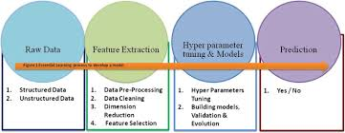

**Data Exploration:**

Step 1: Imported Pandas, Sci-Kit and seaborn libraries to jupyter notebook

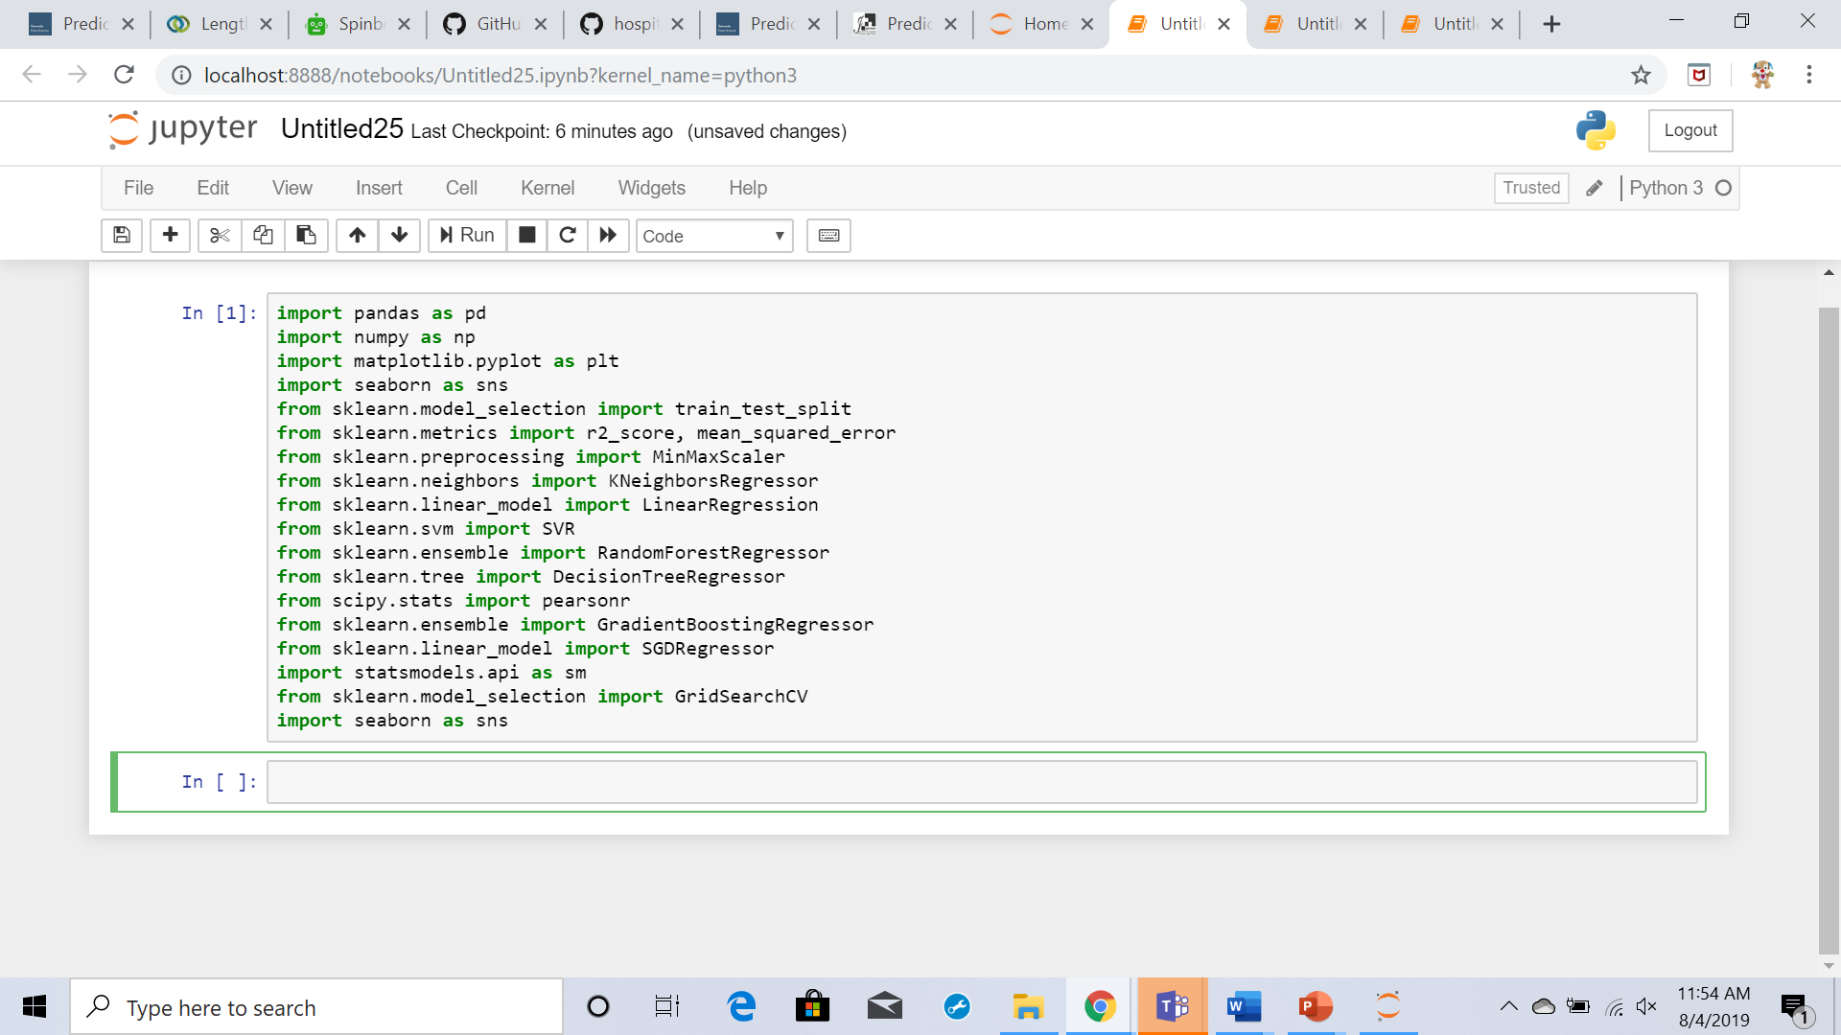

Imported the PATIENTS.csv, ICUSTAYS.csv, DIAGNOSES_ICD.csv and ADMISSIONS.csv to data frames using Pandas libraries

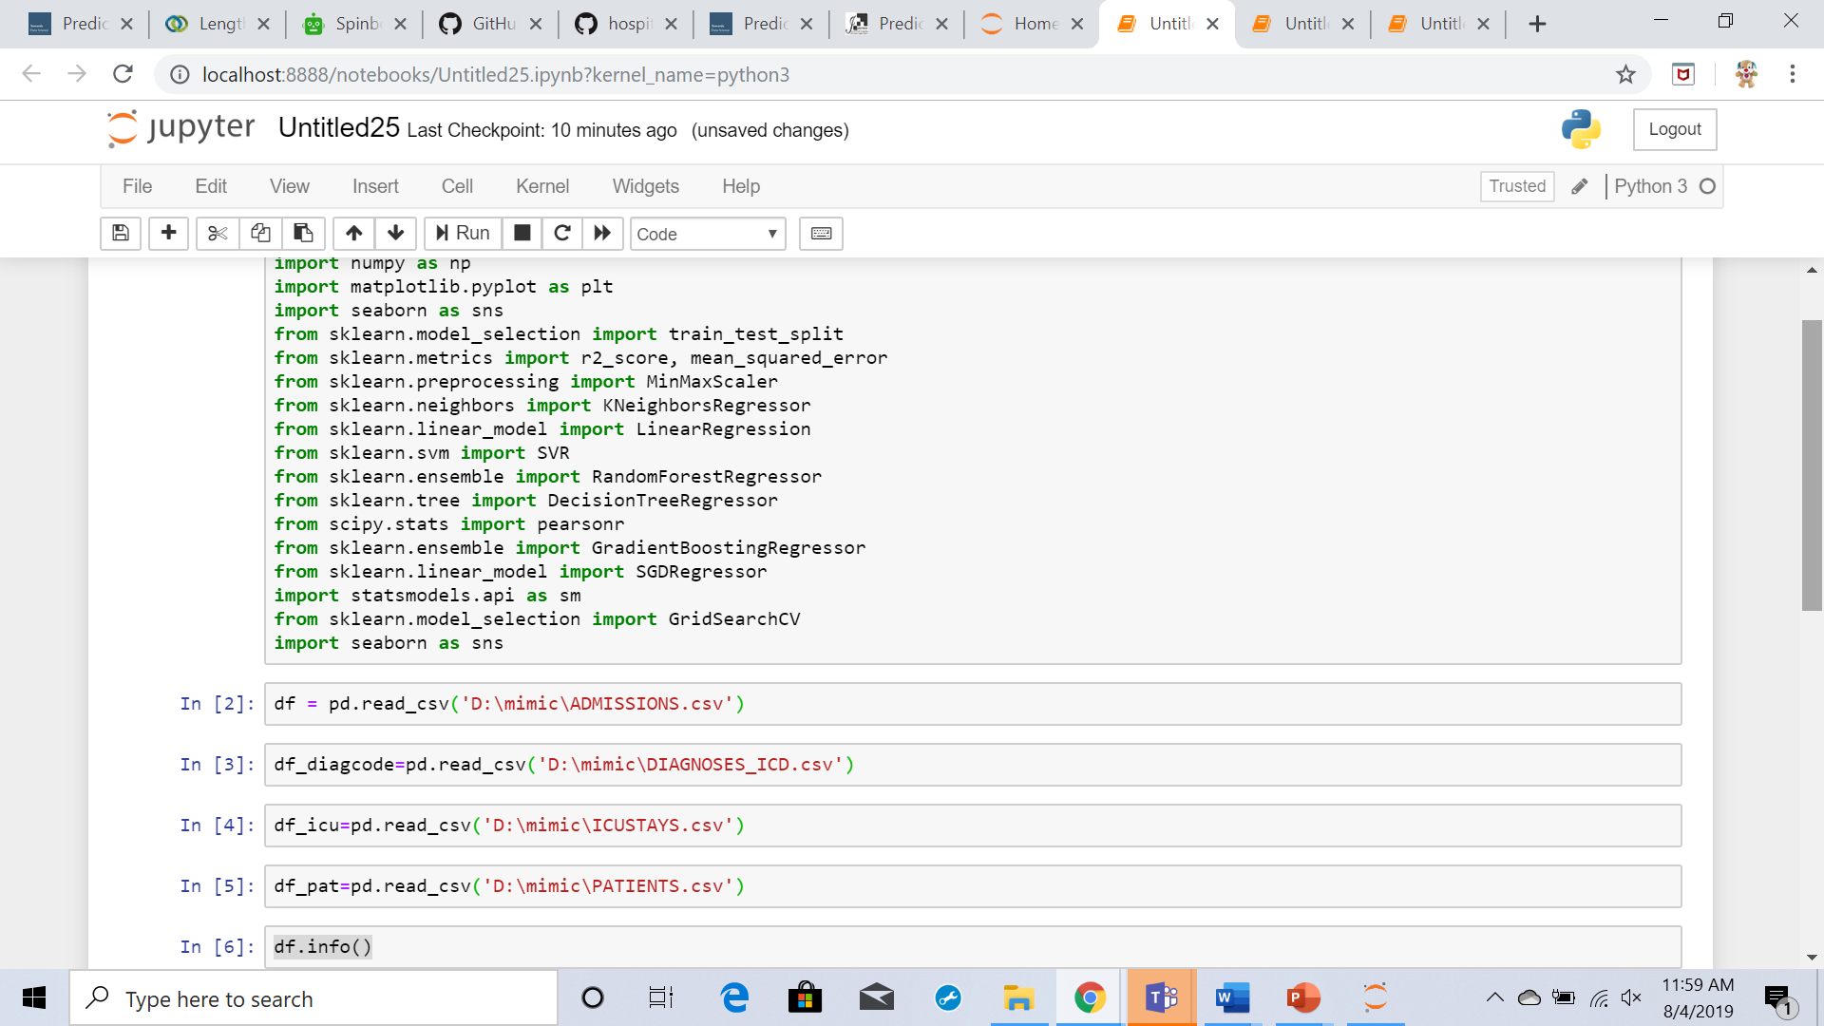

df.info()

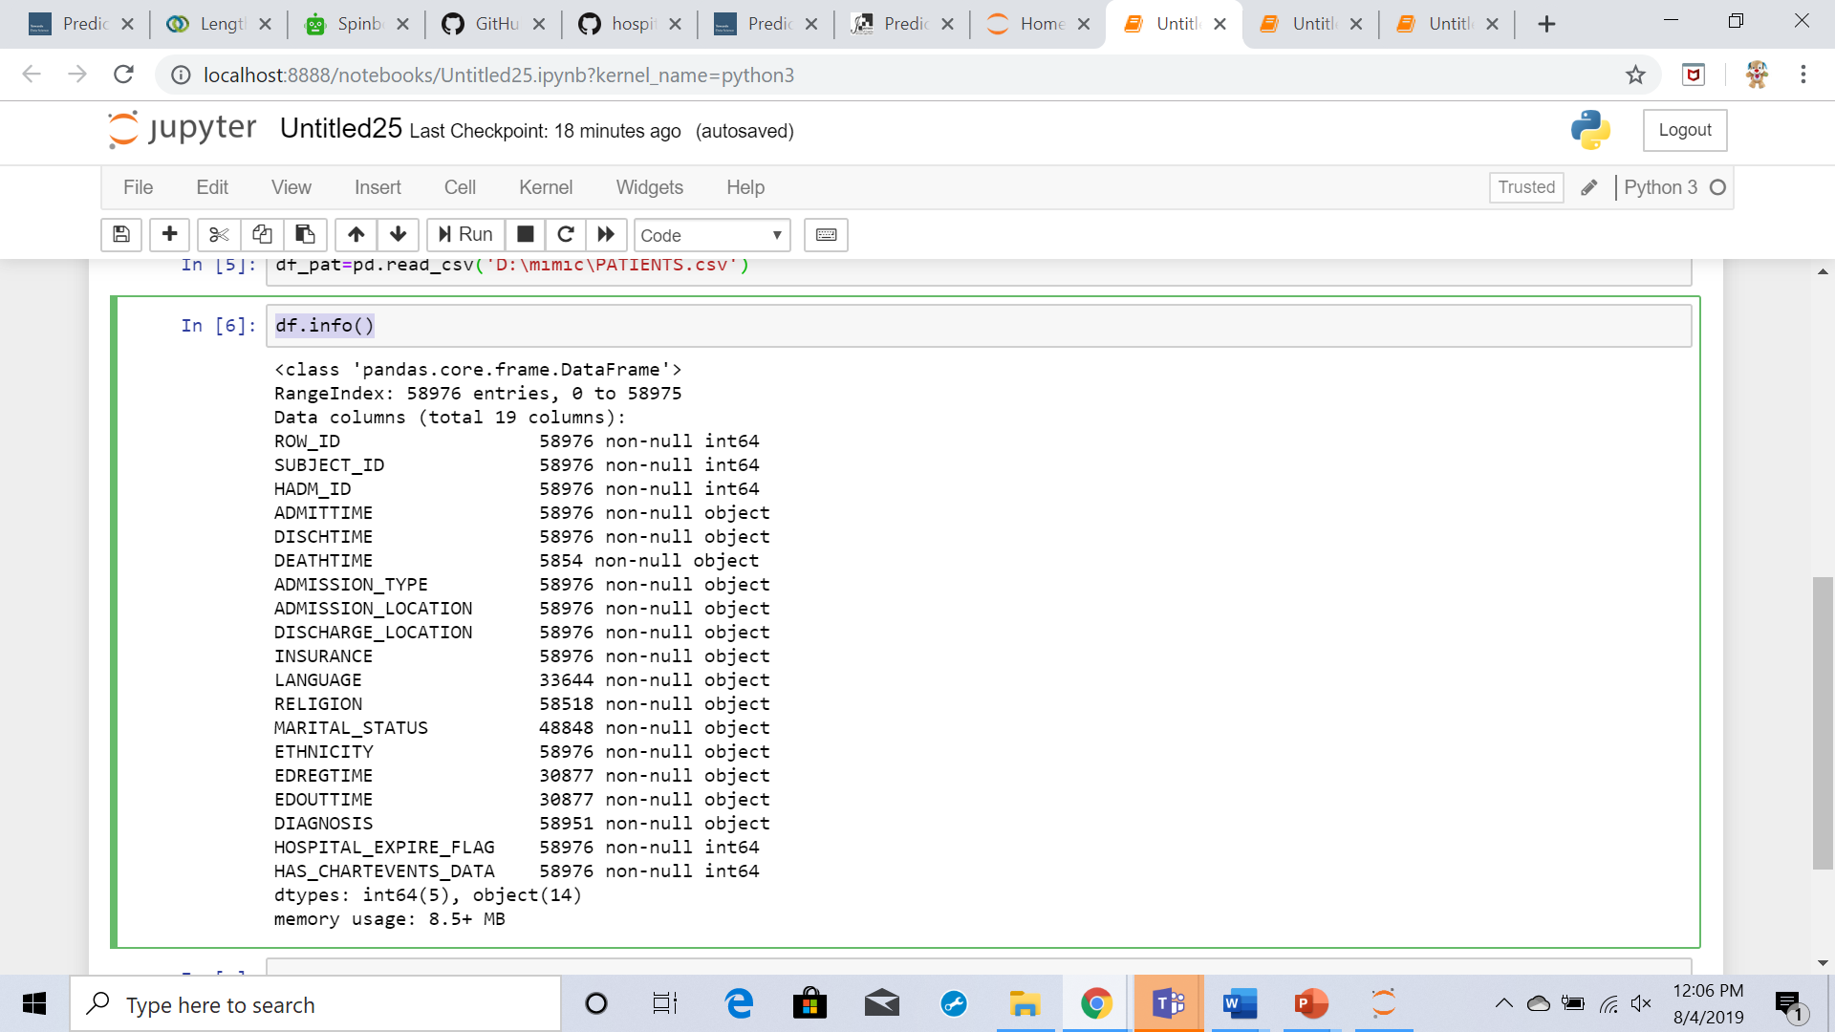

**Unique entries in the Data set:**

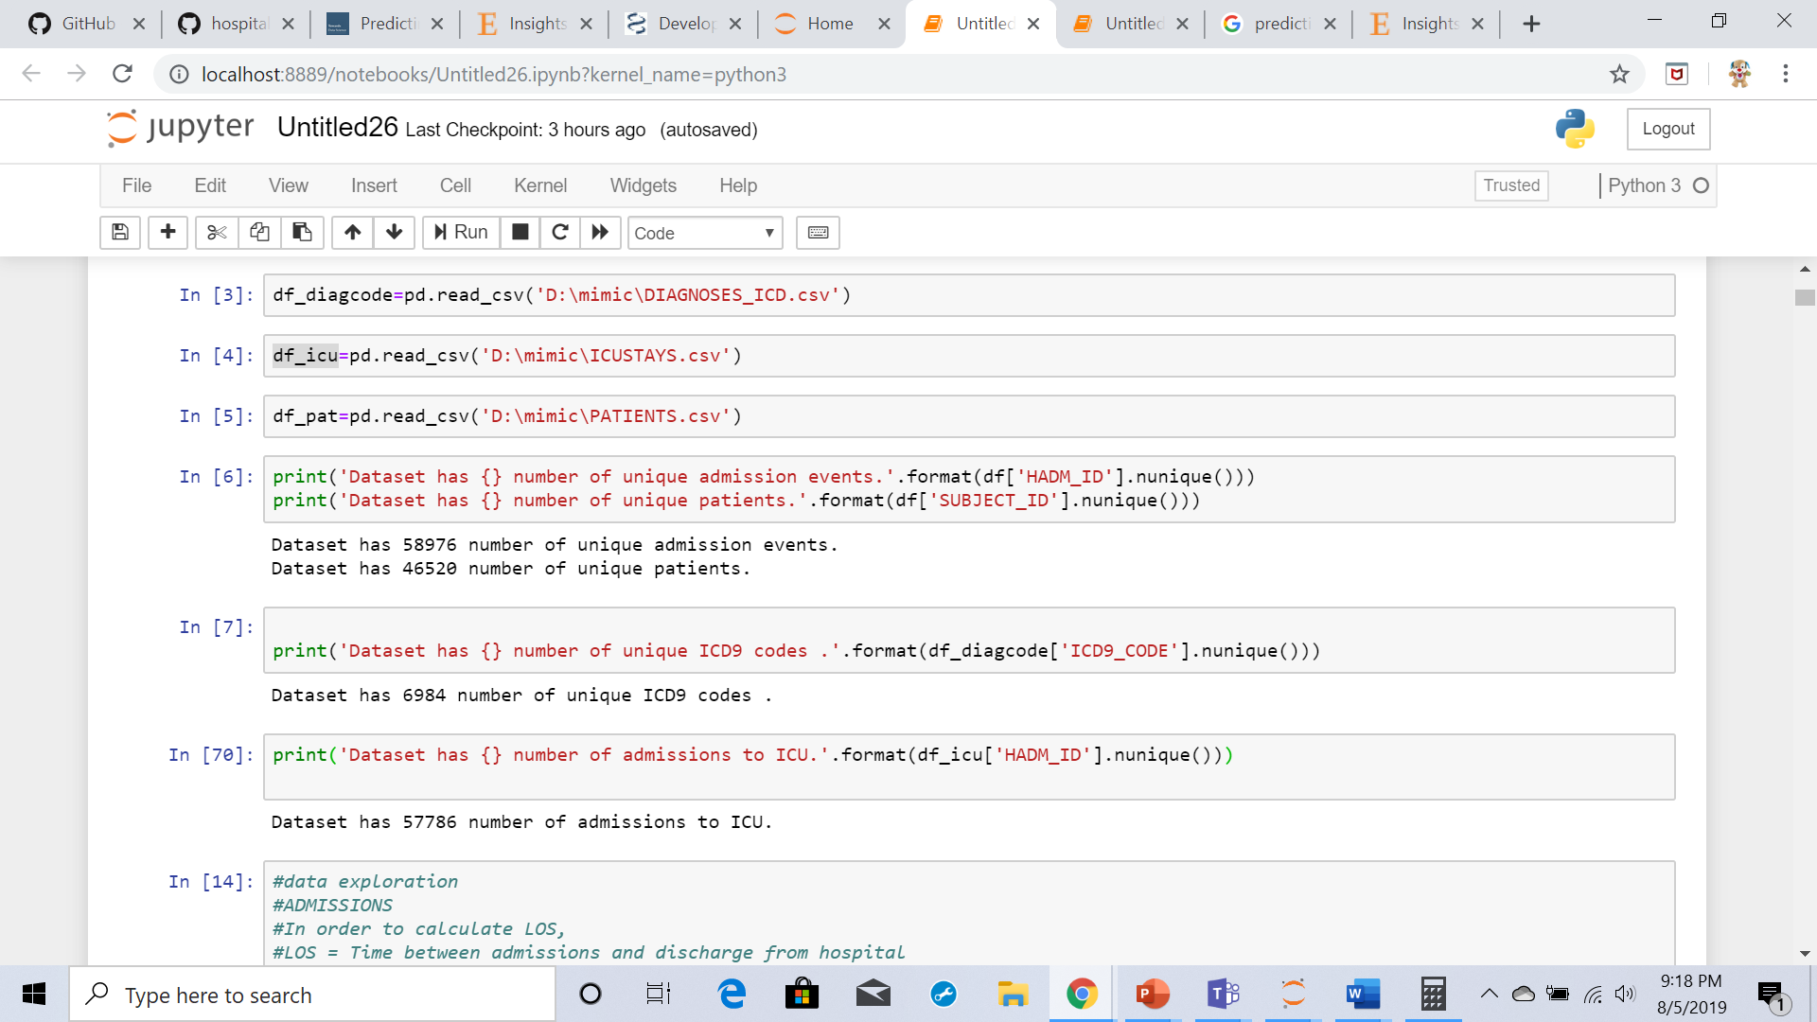

**Admissions.csv exploration:**

In order to calculate LOS,

LOS = Time between admissions and discharge from hospital

The first task is to figure out a way to calculate the LOS. LOS is defined as the time between admission and discharge from the hospital.

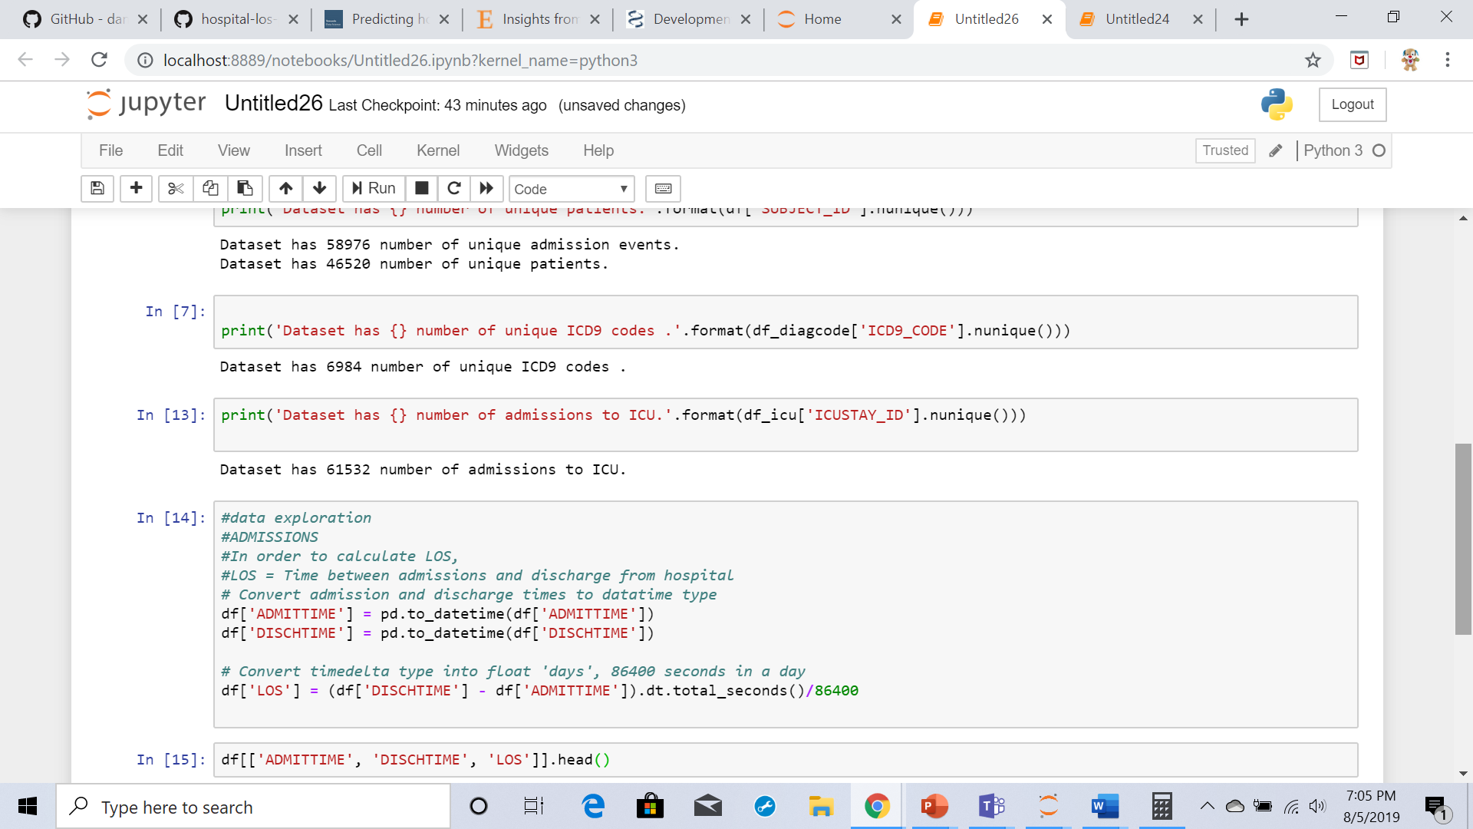

* df[df['LOS'] < 0].count()

There are 98 entries

* df[df['LOS'] > 0]

There are 58878 entries.

**Drop the columns which are not used**

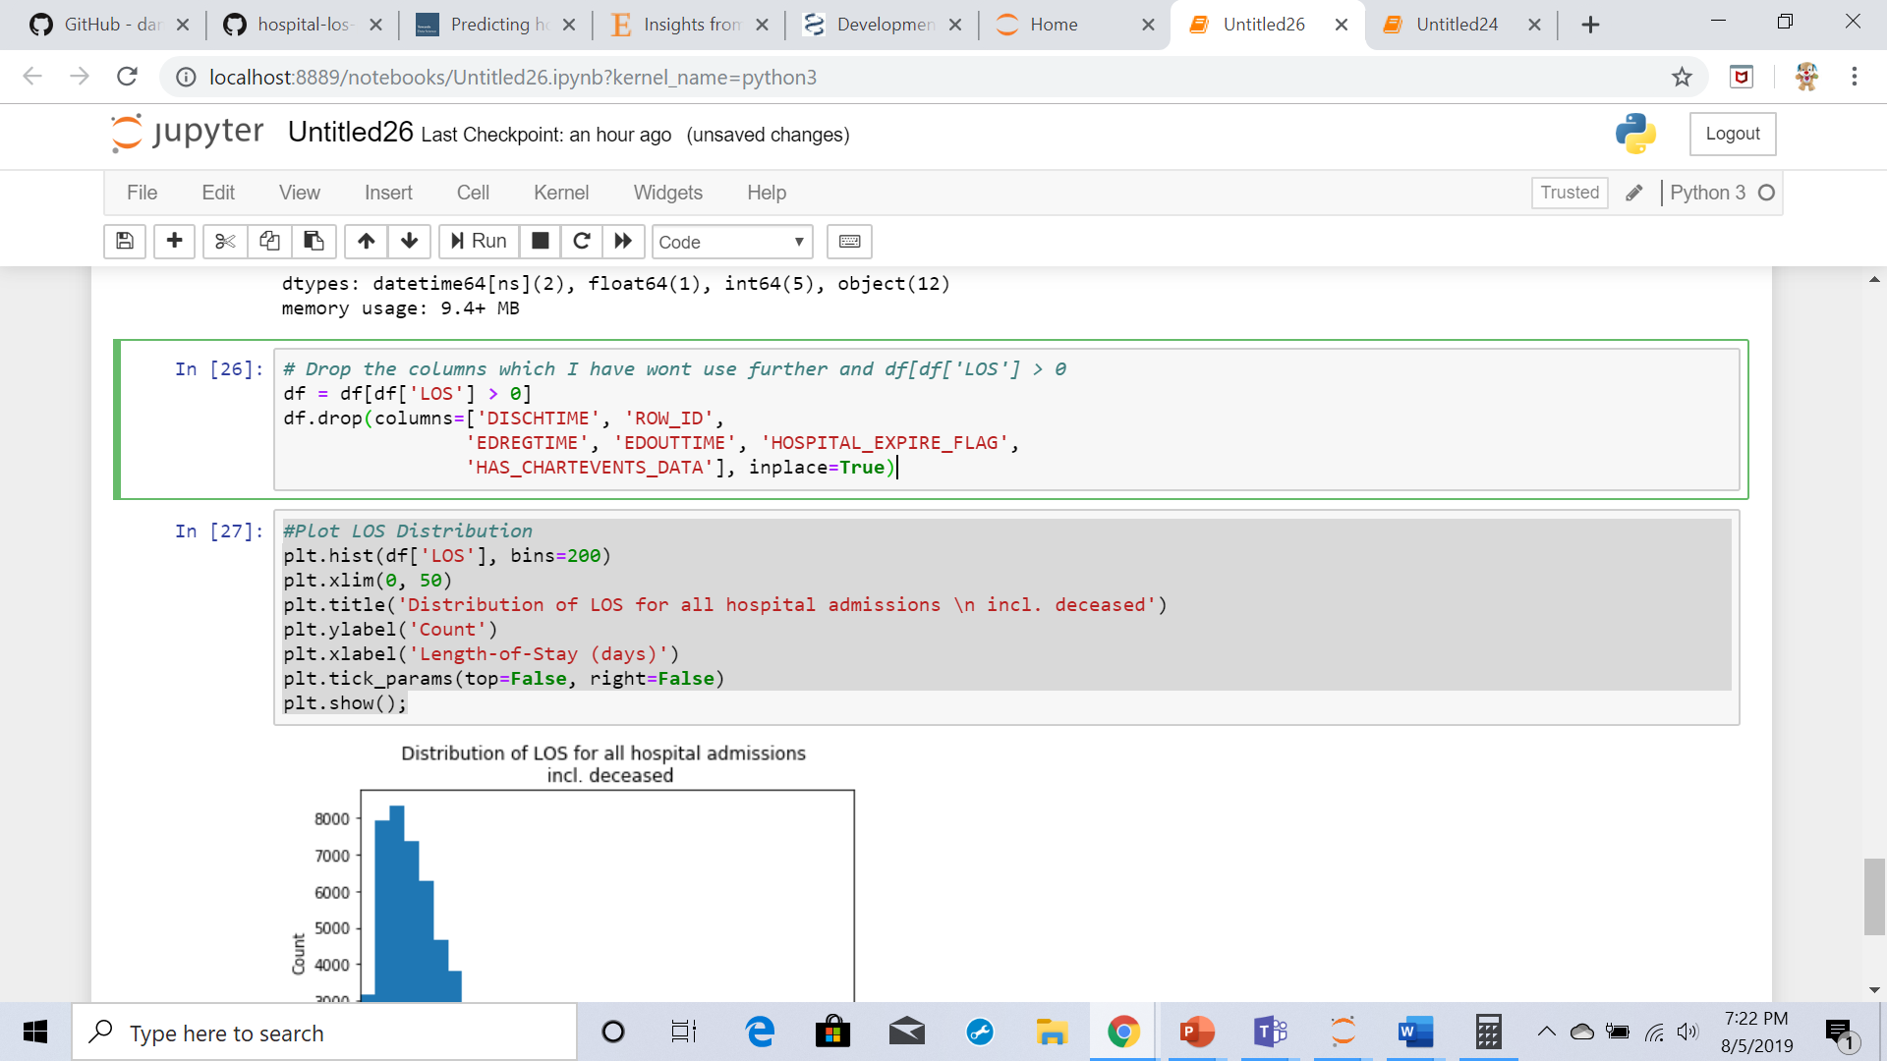

**Distribution of LOS for all hospital admissions:**

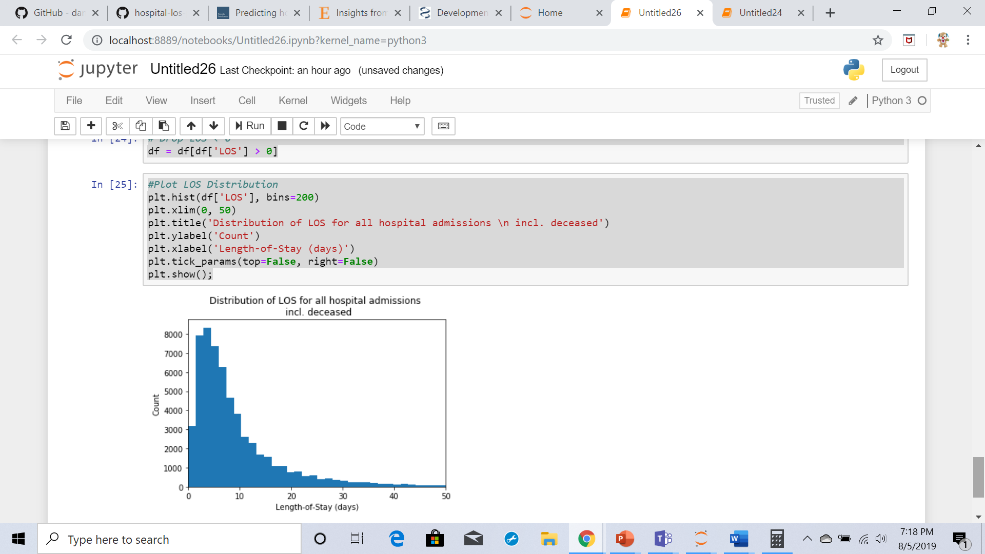

**Death time:**

In order to calculate Los with an unbiased rate I have to drop patients who died from data frame so initially I’m exploring the patients who died in the hospital

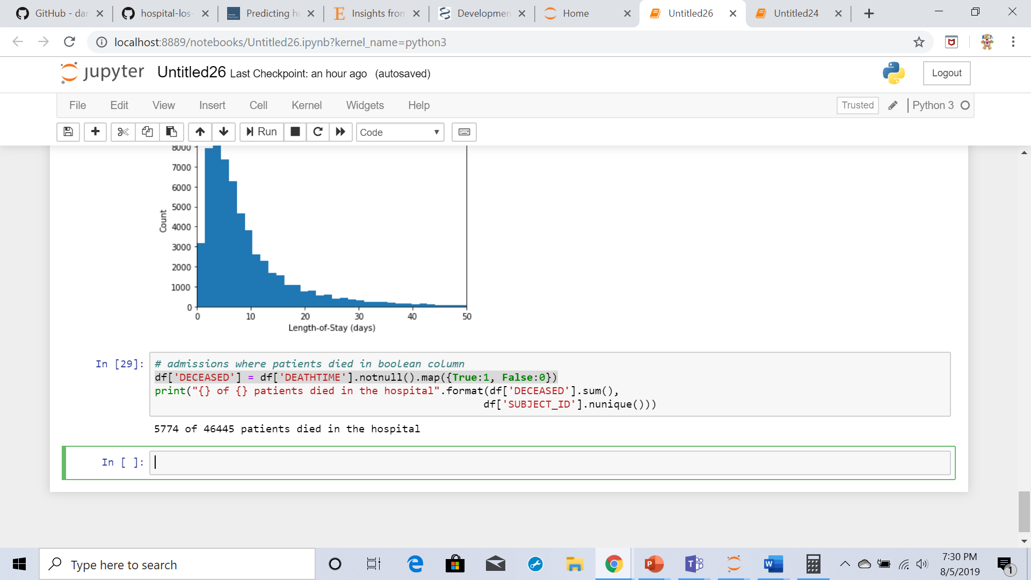

In order to reduce the column to a few categories I am exploring some of the categorical features like ethnicity, religion, insurance and so on

**Ethnicity**:

Compress the number of ethnicity categories:

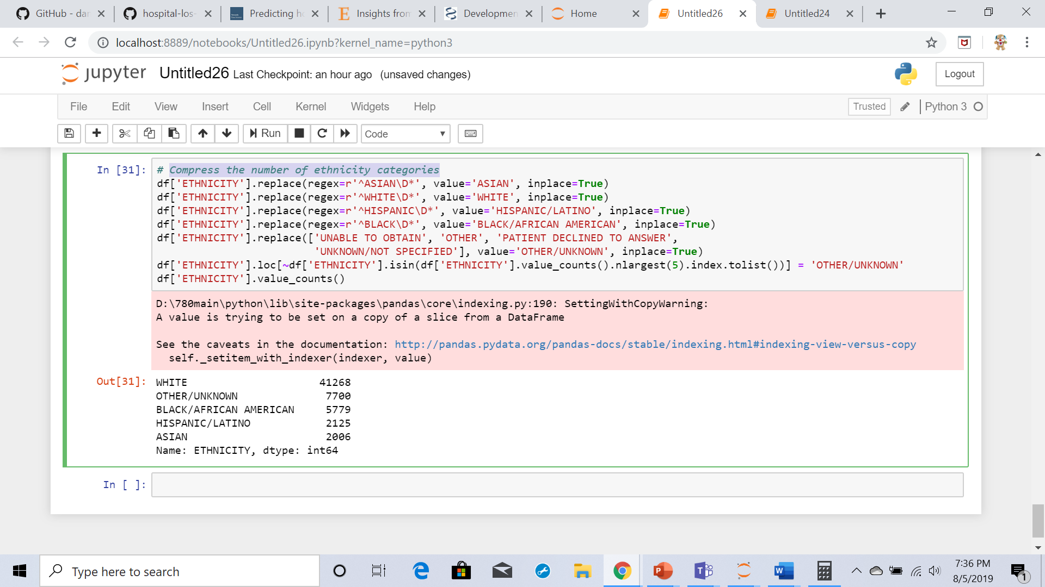



**Admission Type:**

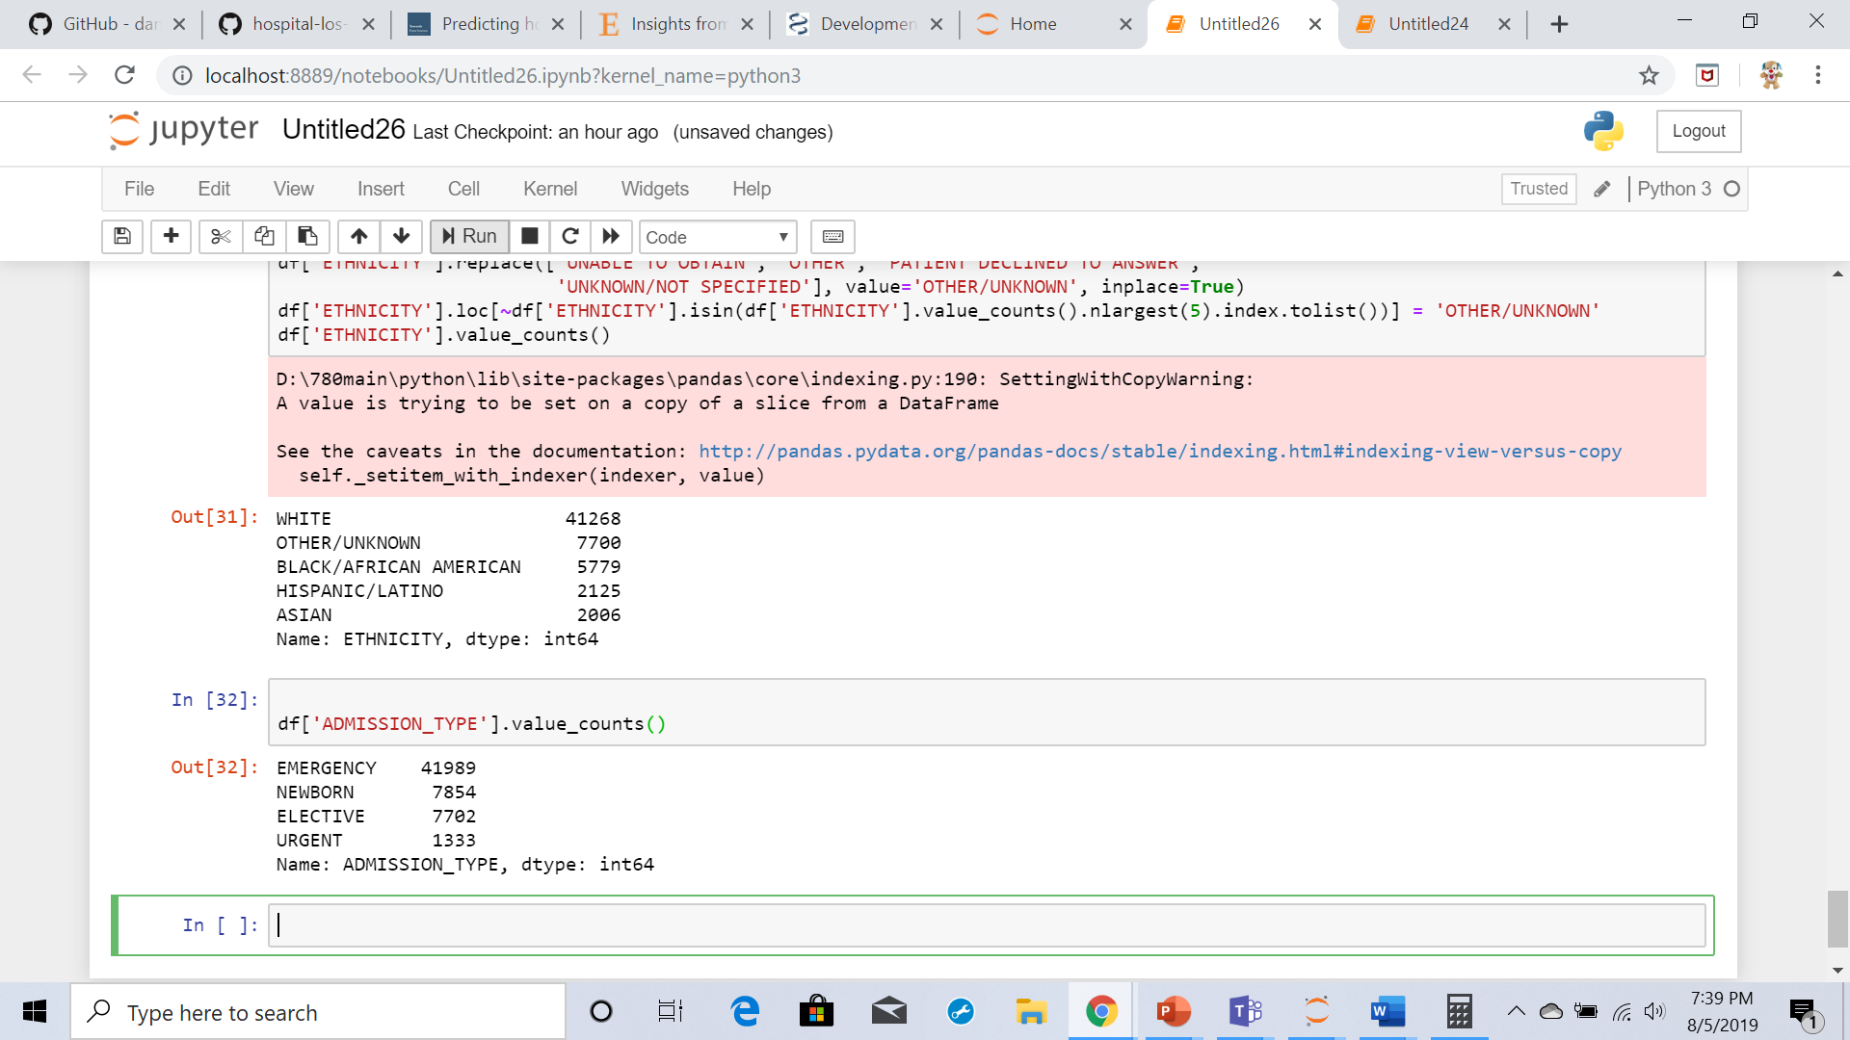

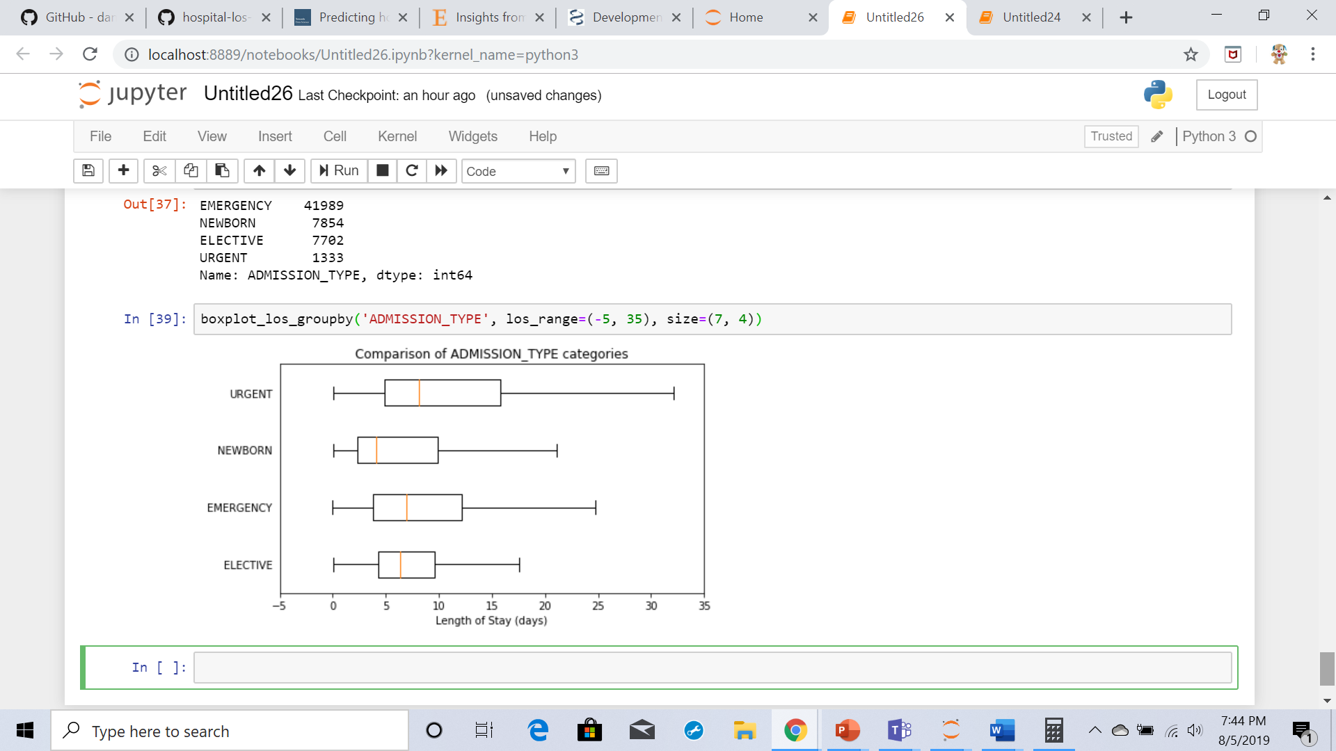

Newborns have the lowest median LOS followed by elective admissions. The reason might be as these are often somewhat planned for and with the risks being understood.

Insurance:

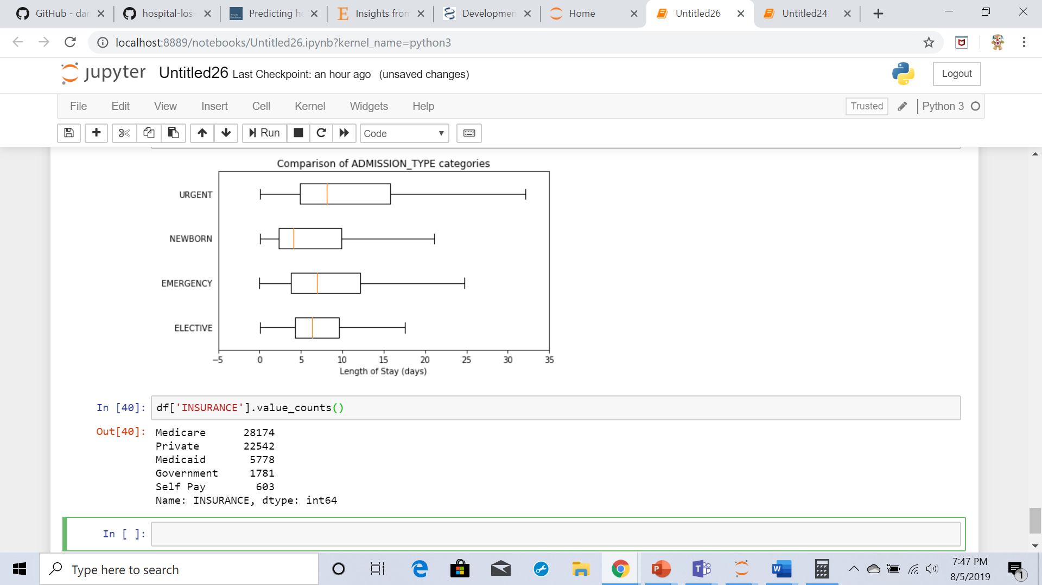

'Self-Pay' patients have the lowest LOS. Where as Medicare patients have highest LOS

**ICUSTAYS.csv data exploration:**

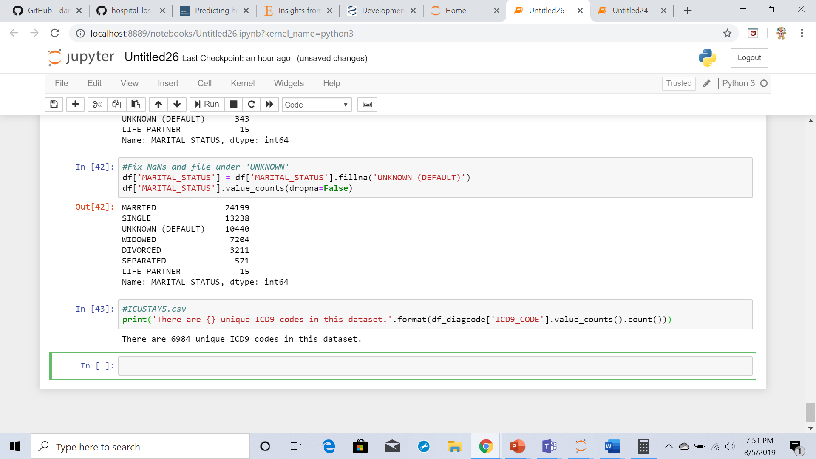

There are 6984 unique ICD9 codes to predicting LOS in the data set I have Recoded the icd9

codes

* 001–139: infectious and parasitic diseases
* 140–239: neoplasms
* 240–279: endocrine, nutritional and metabolic diseases, and immunity disorders
* 280–289: diseases of the blood and blood-forming organs
* 290–319: mental disorders
* 320–389: diseases of the nervous system and sense organs
* 390–459: diseases of the circulatory system
* 460–519: diseases of the respiratory system
* 520–579: diseases of the digestive system
* 580–629: diseases of the genitourinary system
* 630–679: complications of pregnancy, childbirth, and the puerperium
* 680–709: diseases of the skin and subcutaneous tissue
* 710–739: diseases of the musculoskeletal system and connective tissue
* 740–759: congenital anomalies
* 760–779: certain conditions originating in the perinatal period
* 780–799: symptoms, signs, and ill-defined conditions
* 800–999: injury and poisoning
* E and V codes: external causes of injury and supplemental classification, using 999 as placeholder even though it overlaps with complications of medical care

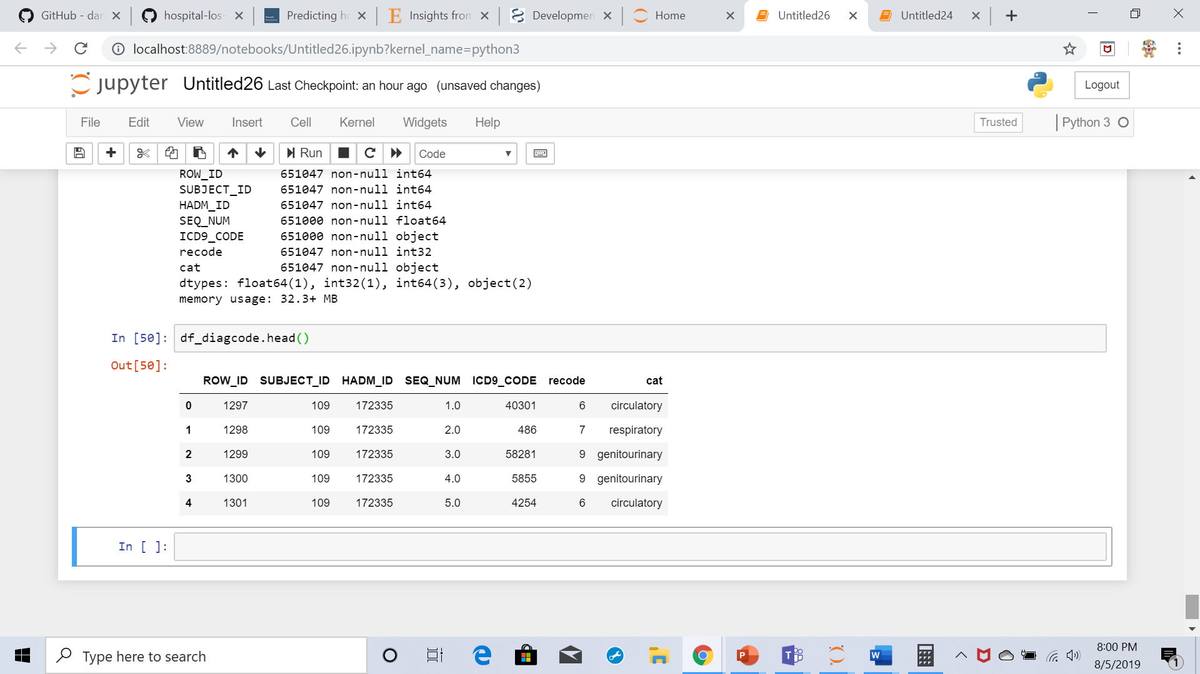

Since for each admission, usually there could be more than one diagnosis. Often, there are more than 1 diagnoses for 1 category. So, I have created a dummy matrix that highlights all the diagnoses for each admission.

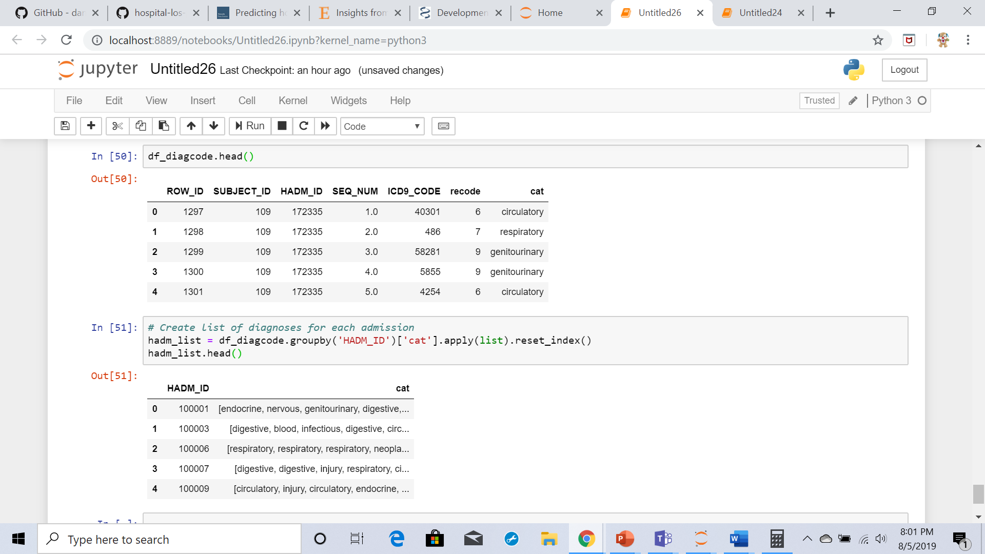

**Median LOS by diagnosis category:**

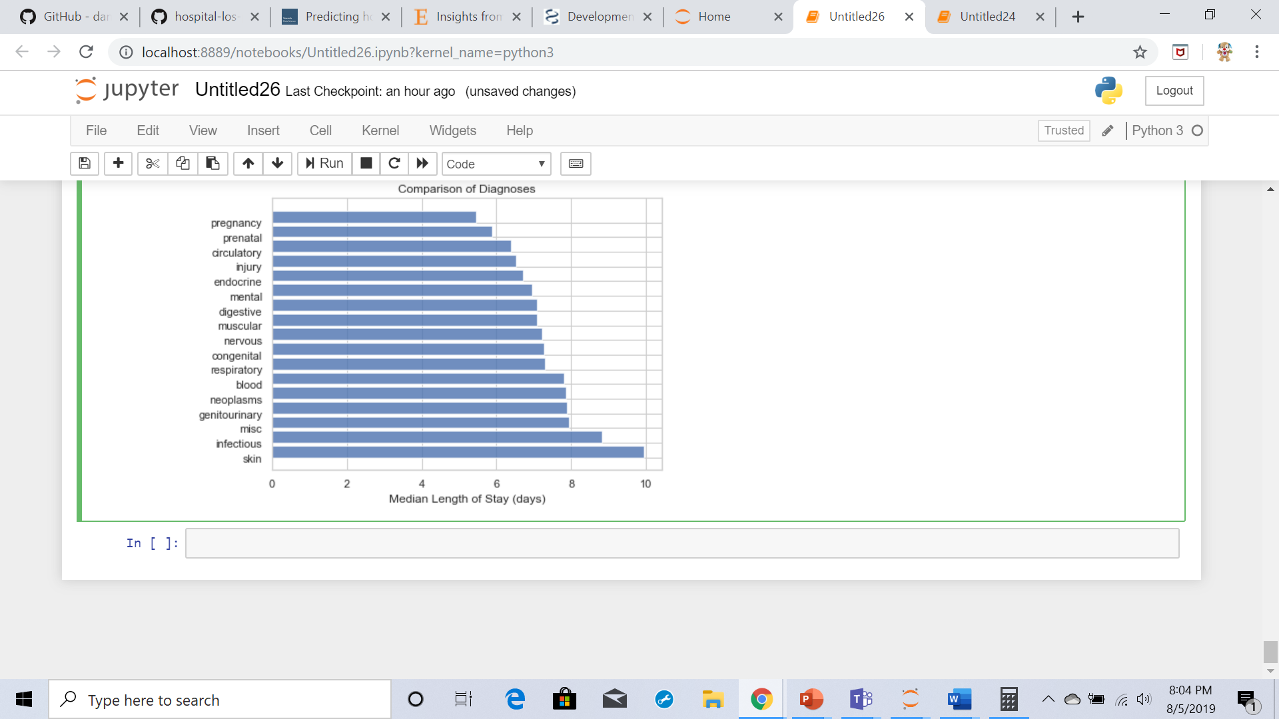

**PATIENTS.csv exploration:**

This table provides age and gender information

**Gender:**

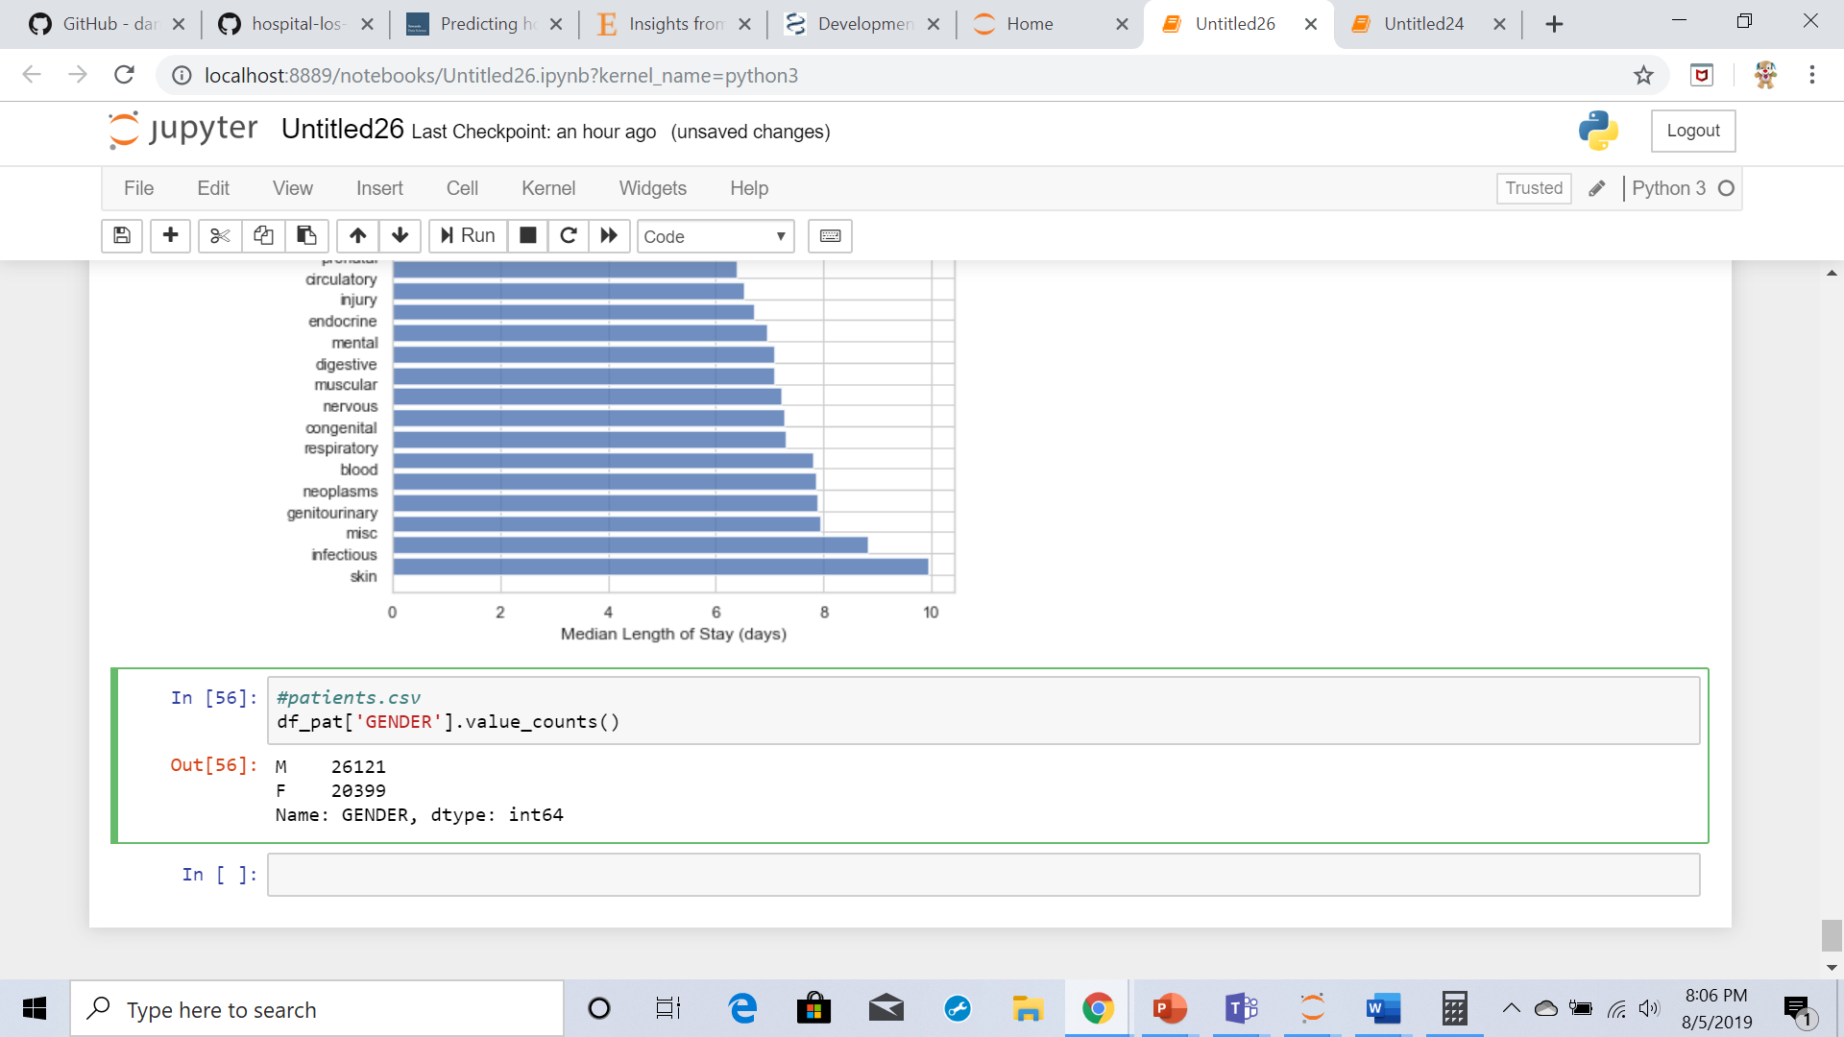

There are 26121 male patients and 20399 female patients

**Age**:

I have the calculated age from admissions data frame as it is having DOB column.

Age is decode by finding the difference in admission date and date of birth

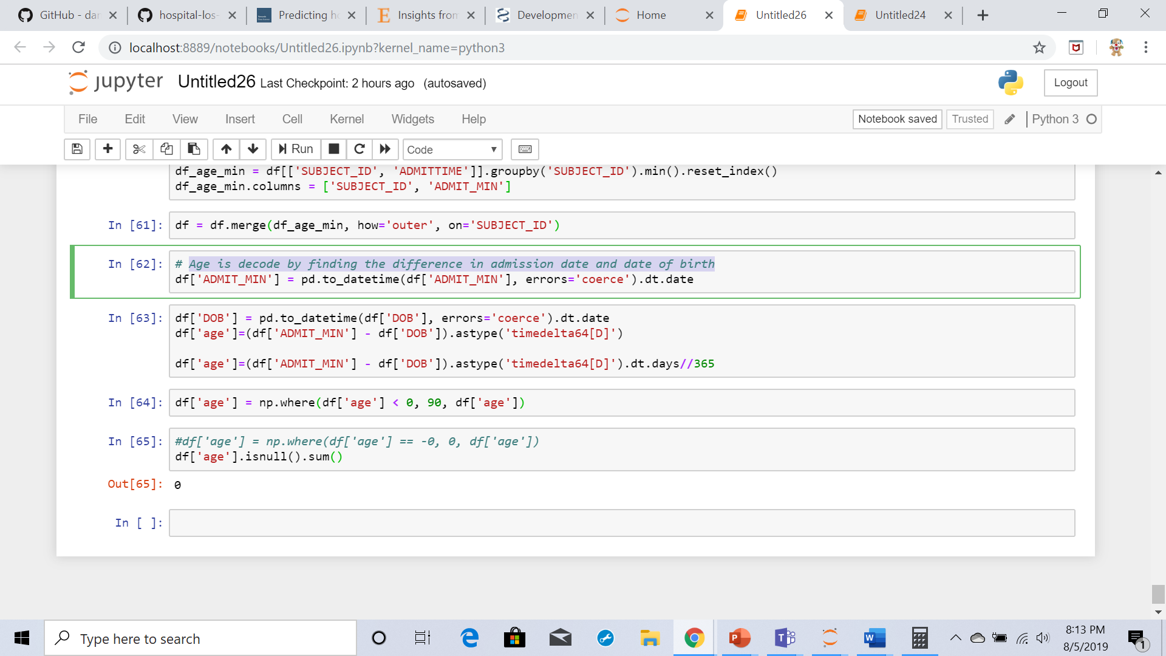

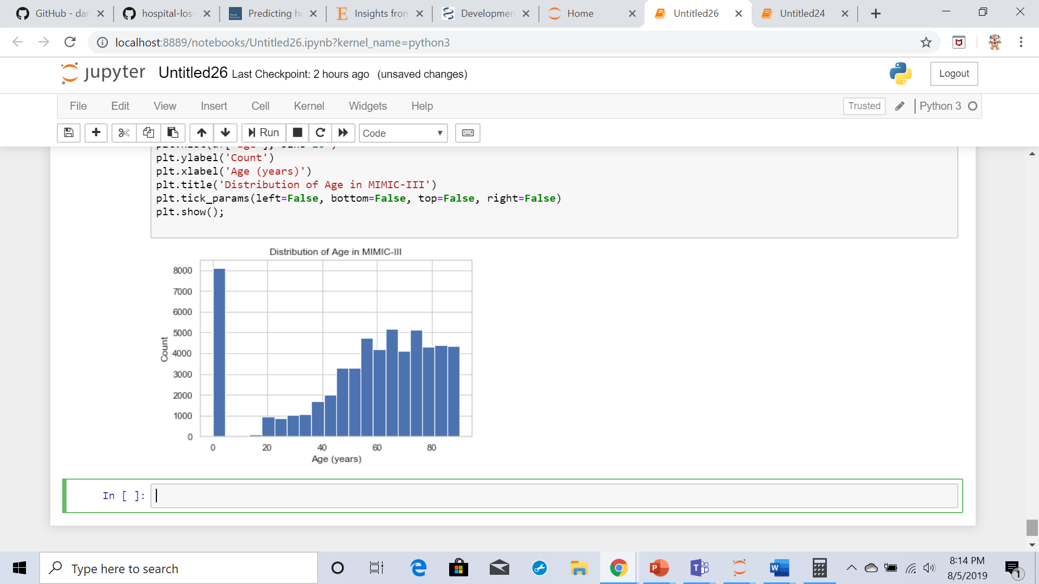

**Age vs Length of stay:**

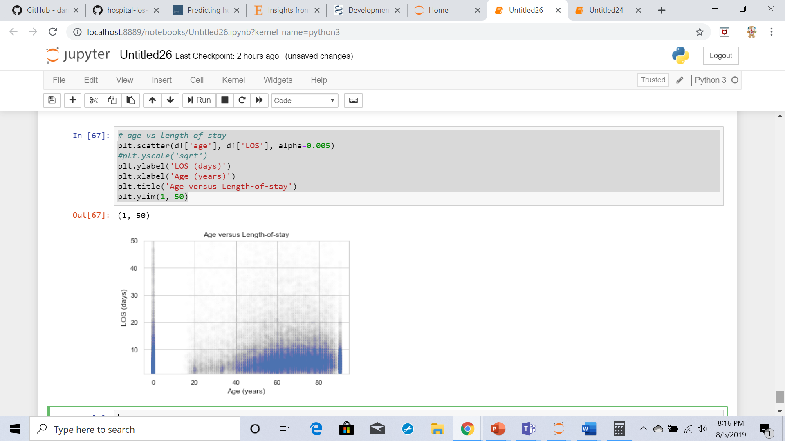

**ICUSTAY.csv exploration:**

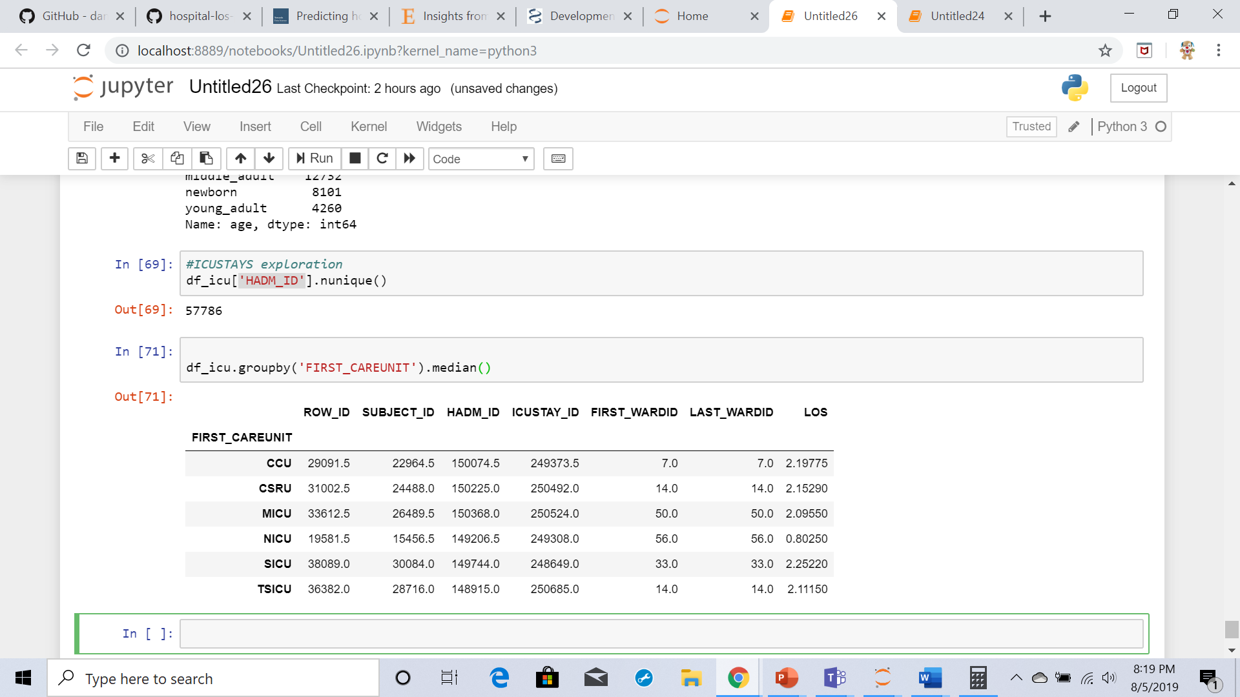

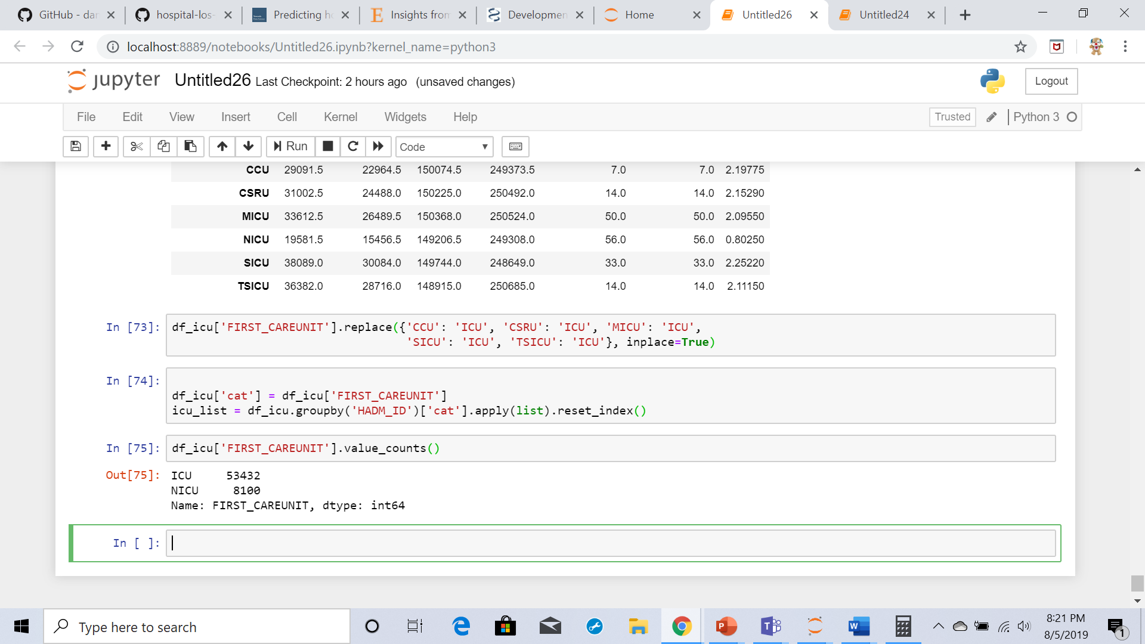

There are 53432 ICU and 8100 NICU patients in the First care unit.

Merge ICU data to main data frame:

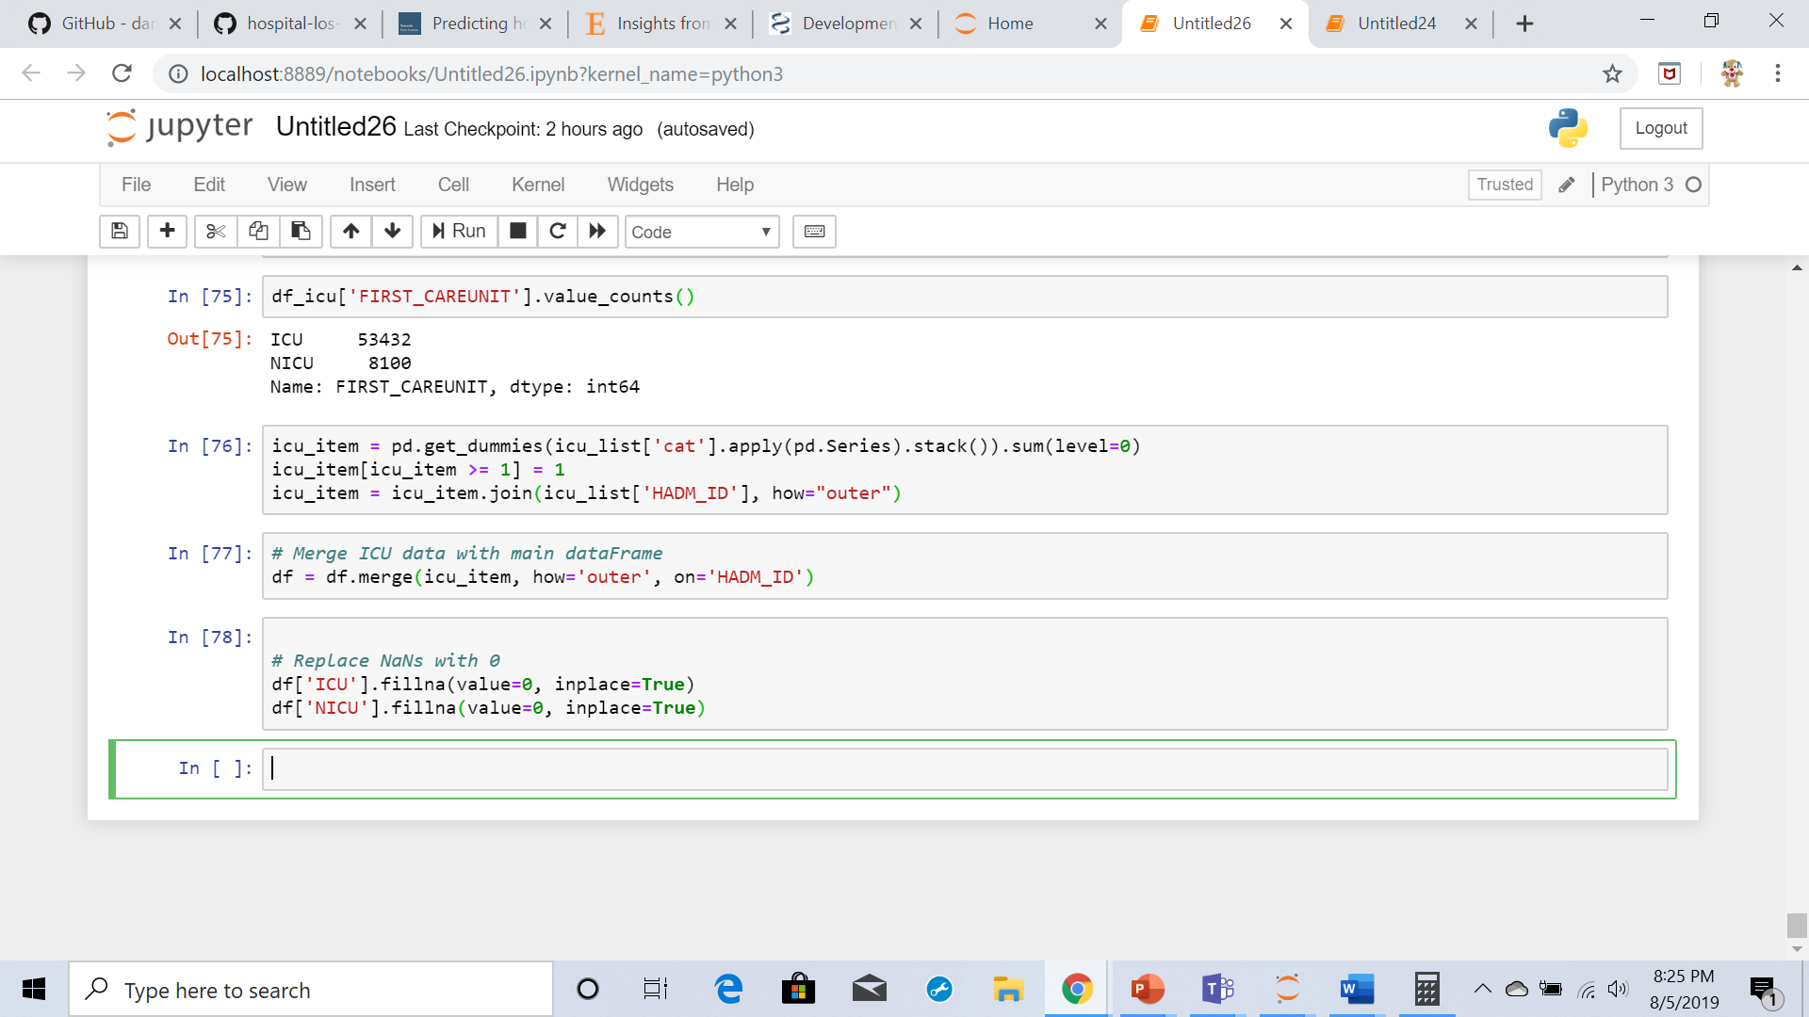

**Data preprocessing:**

Now the final Data Frame size resulted in 48 feature columns and 1 target column with an entry count of 53,104

I have dropped the columns which are not used further.

mimic_los_cleanup: function is used to clean the data further to predict a model. This function take 4 csv files from the MIMIC-III database, converts them to DataFrames for cleanup and feature engineering for use in a Length-of-Stay regression model

It performs all the above cleaning activities which I have performed at data exploration stage.

Create dummy columns for categorical variables:

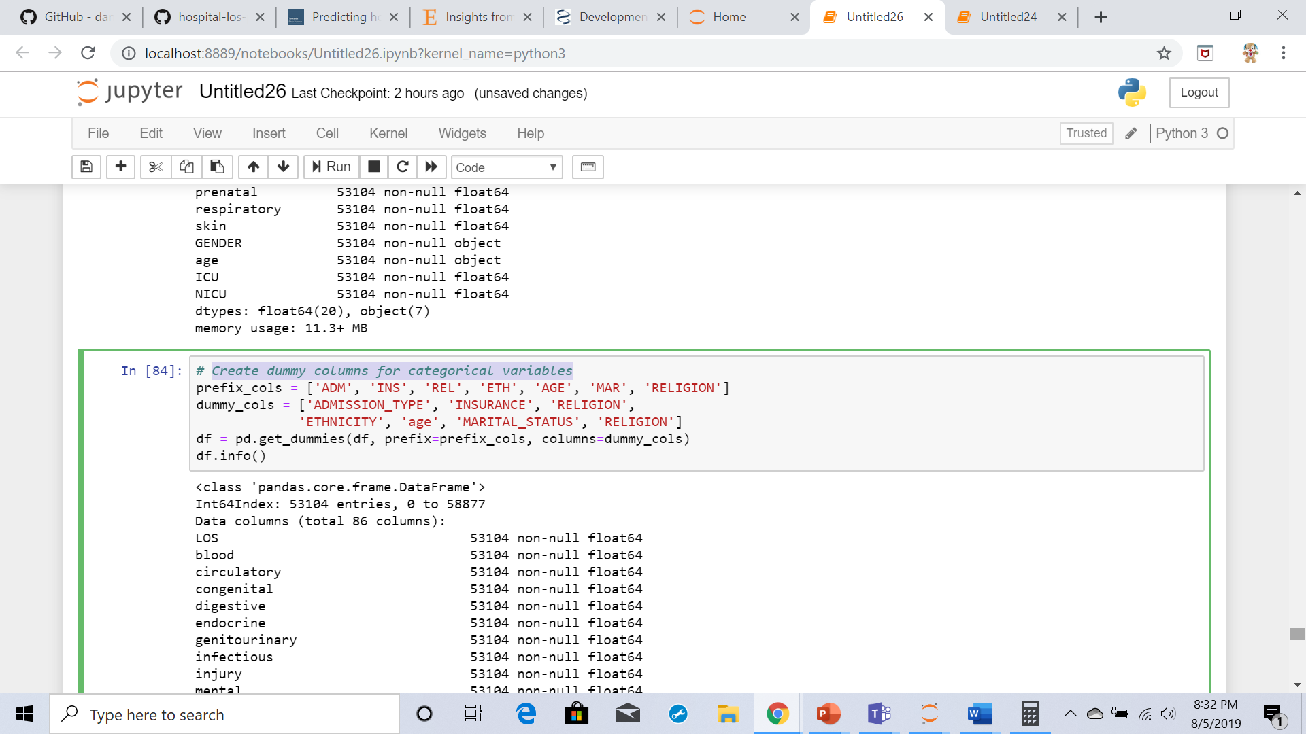

df_clean.info(verbose=1)

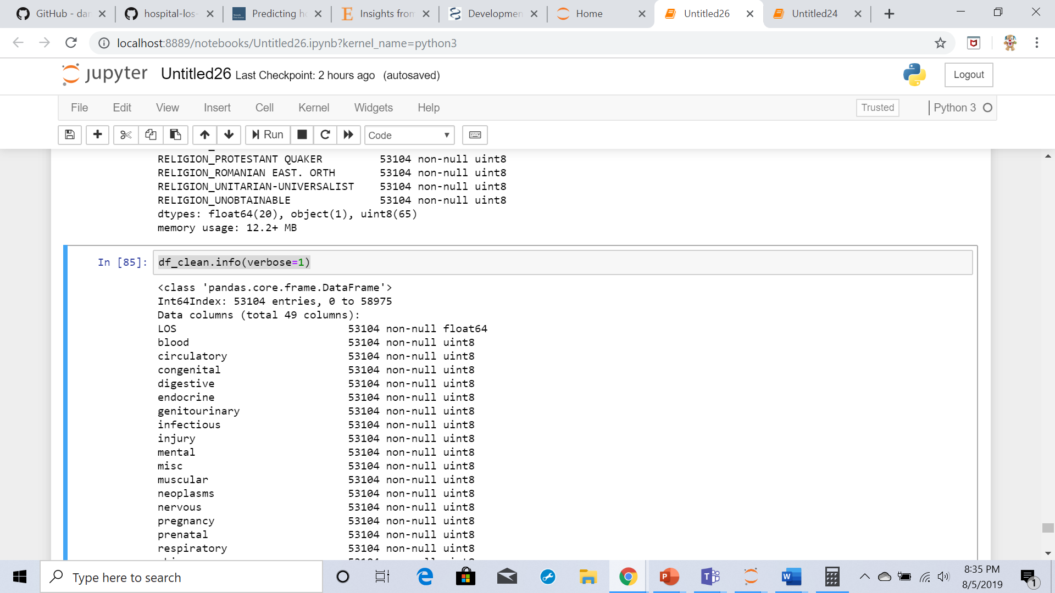

After data clean up there are 49 columns

**Model Building**:

The LOS target variable and features data is divided into 80:20 ratio training and test sets using the scikit-learn train_test_split function.

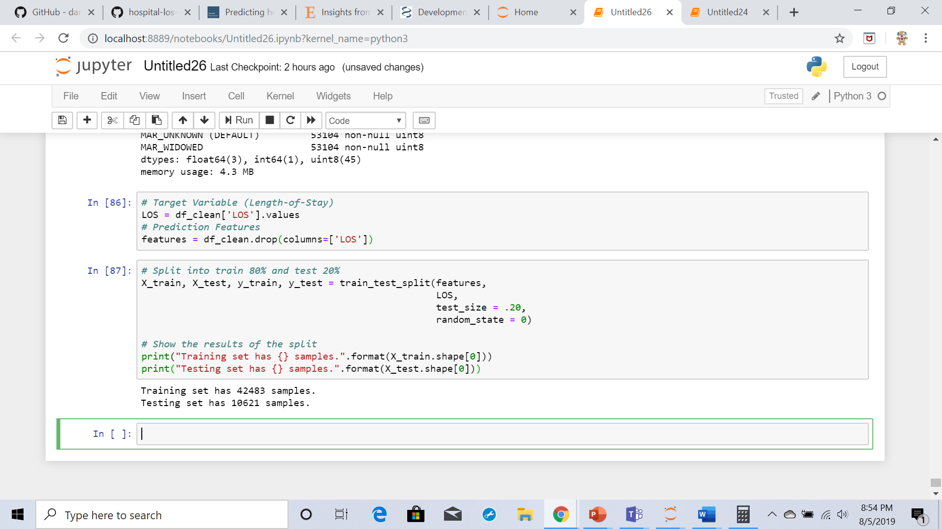

The data set is divided into training and testing set with 42483 for training set and 10621 for testing set

I have used five different regression models ( SGD Regressor, Gradient Boosting Regressor, Linear Regression, K Neighbors Regressor and Random Forest Regressor)is compared to see R2 score to find the best model.

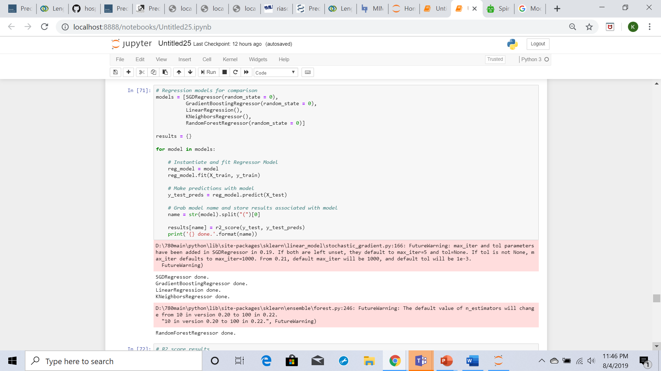

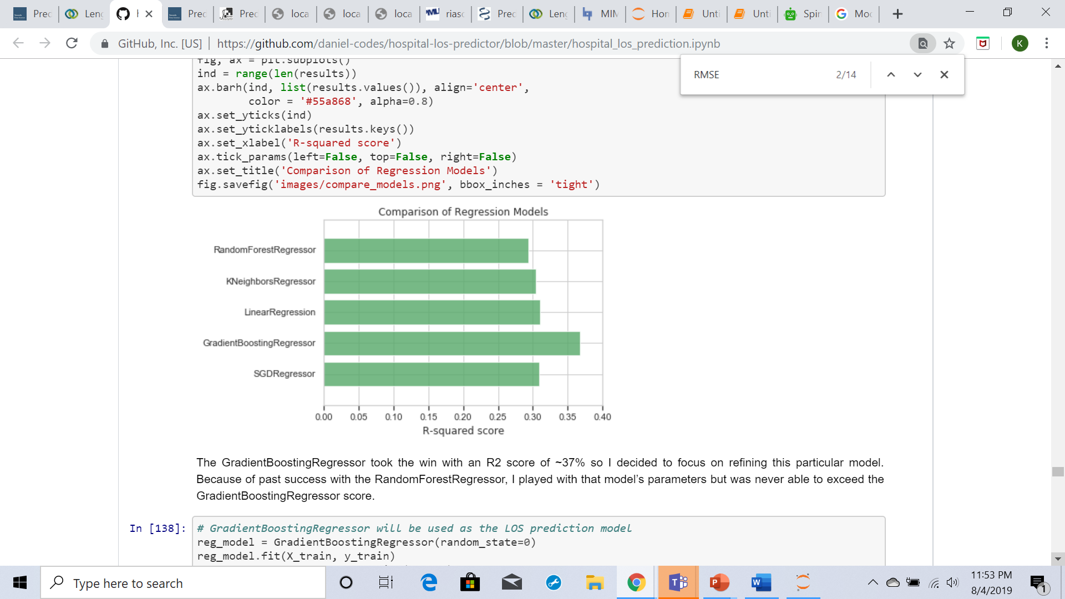

Among all the regression models GradientBoostingRegressor with an R2 score of ~37% is the best .

**Model Evaluation:**

R2 score: To determine the best regression, model the R2 (R-squared) score will be used.

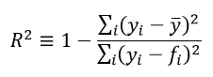

(y_i) = observed data point,

(ŷ) is the mean of the observed data

(f_i) the predicted model value.

Best possible R2 score is 1.0 and a negative value means it is worse than a constant model, or median

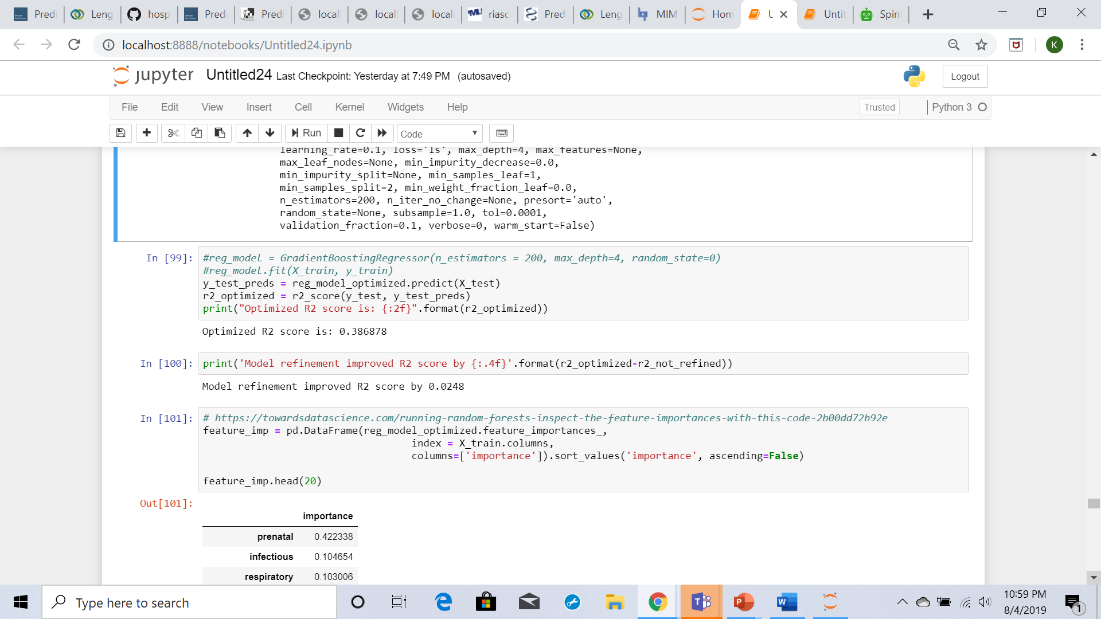

Optimized R2 score is: 0.386878

Model refinement improved R2 score by 0.0248

**Results:**

Important features to predict hospital length of stay using Gradient boosting regression model:

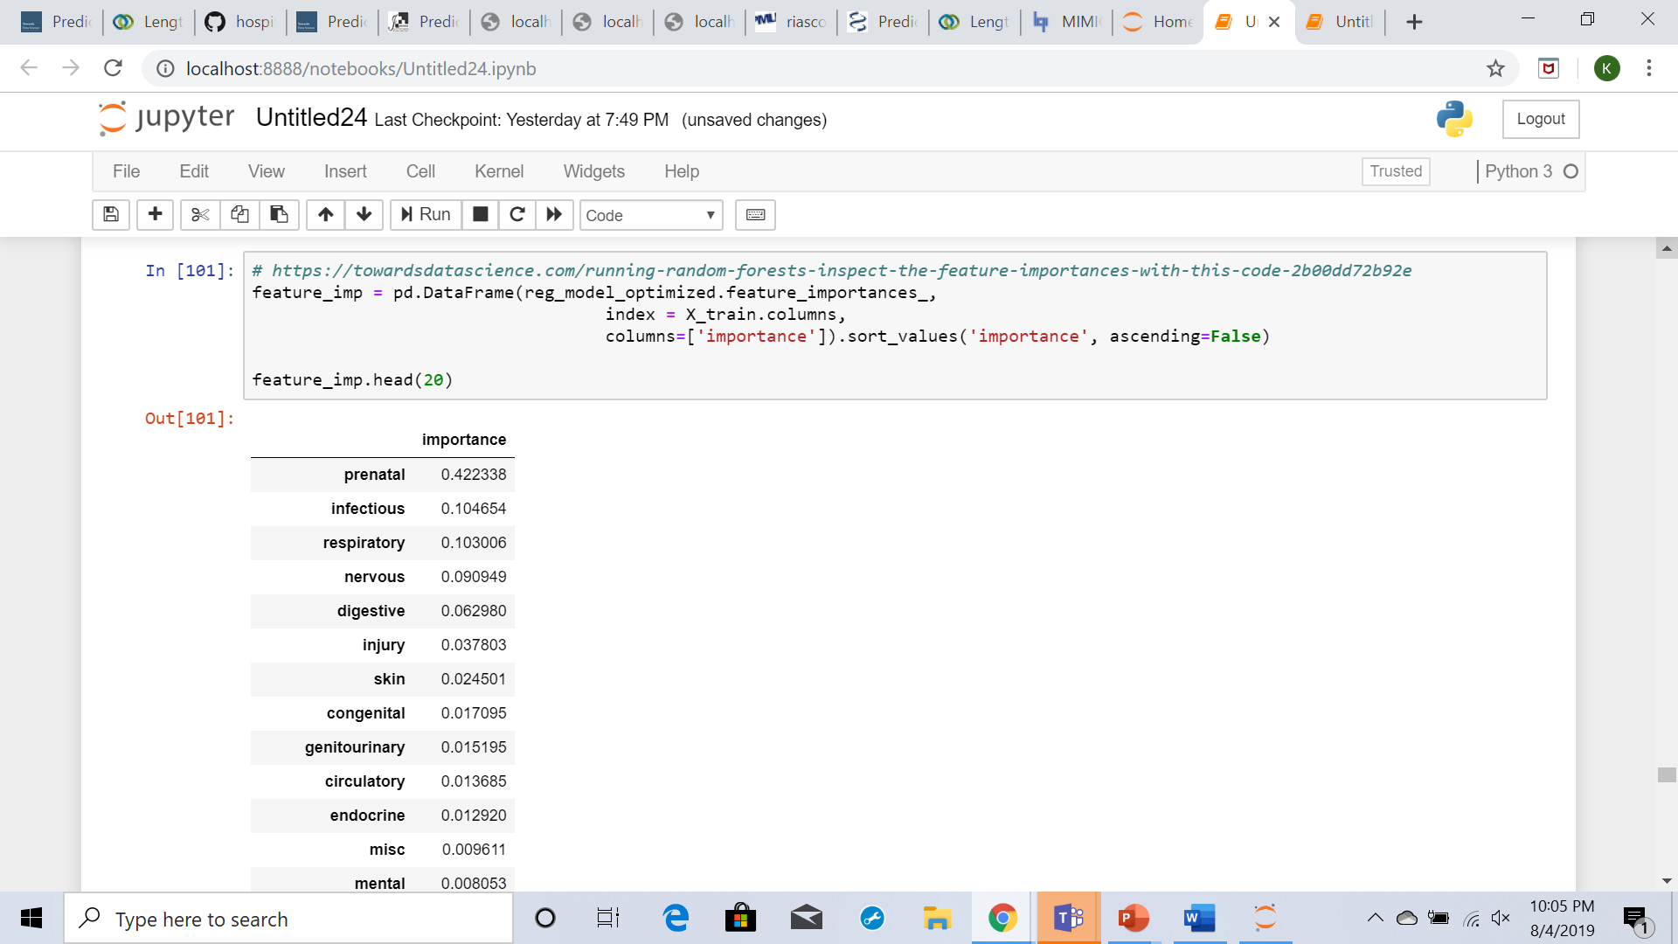

It has been observed that Diagnoses related to prenatal issues have the highest feature importance coefficient followed by respiratory and injury.

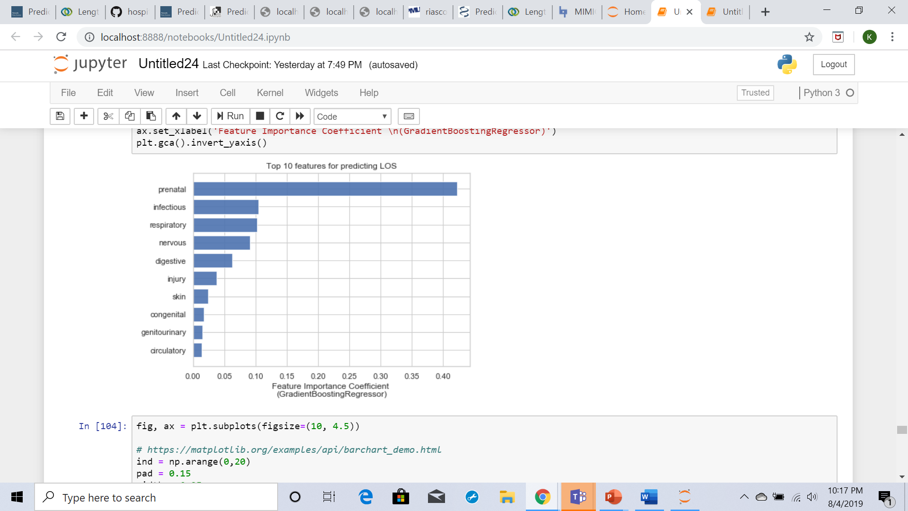

The RMSE is a commonly used measure of the differences between values predicted by a model and the values observed, where a lower score implies better accuracy. The prediction model against the median and average LOS using the root-mean-square error (RMSE).

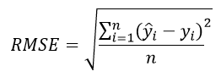

n = number of hospital admission records.

(y-hat) the prediction LOS.

(y) is the actual LOS.

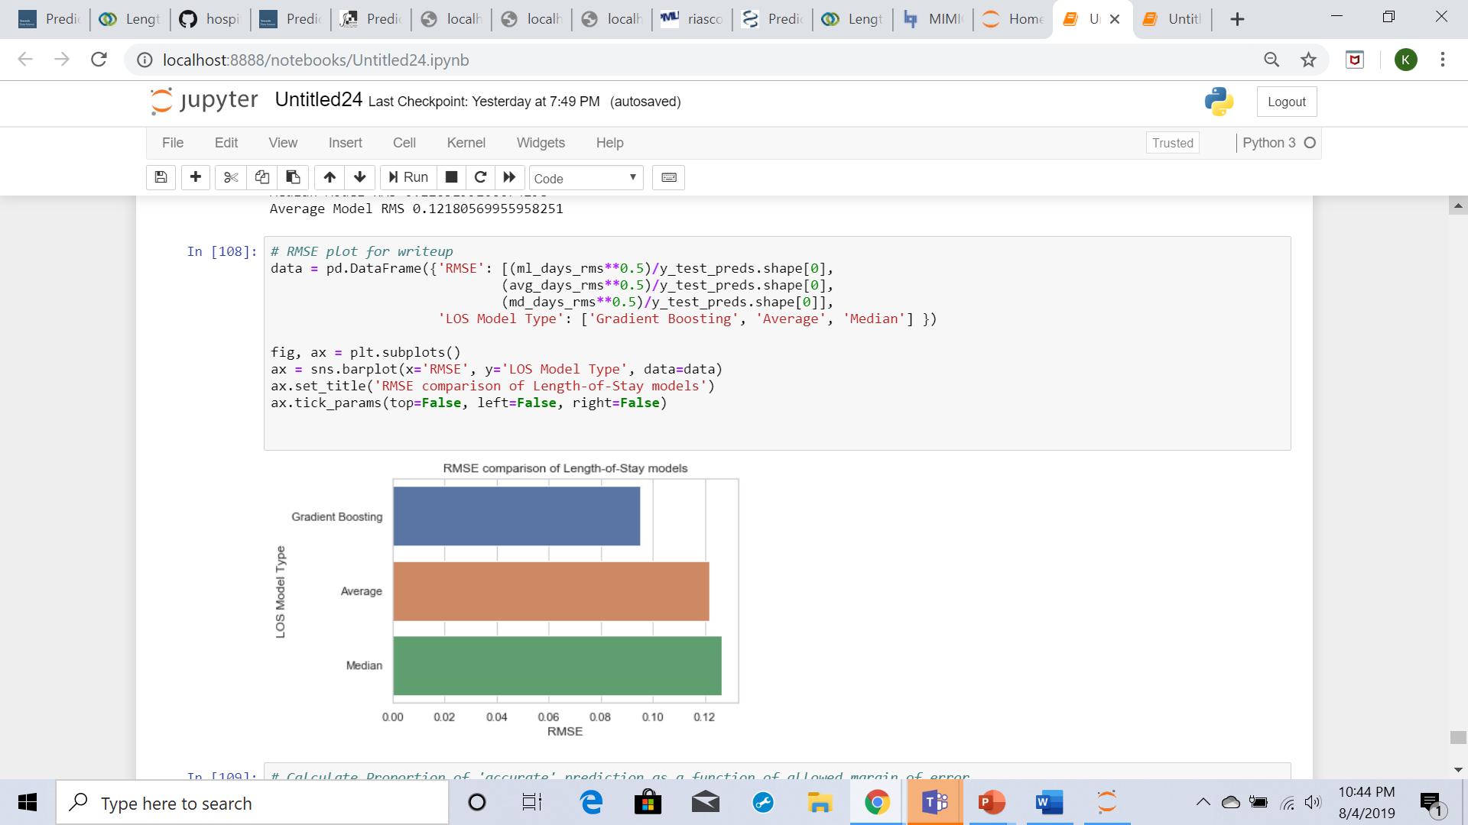

The gradient boosting version RMSE is better (24% difference) Than the average or median models.

**Conclusion:**

MIMIC data base is an openly available database developed by The MIT lab. It has the dataset which I have chosen to predict Patients length of stay at the time of admission has 58976 number of unique admission events and 46520 number of unique patients. It has been noticed that ICD9 play a critical role than age when predicting the length-of-stay. I have used five different regression models (SGD Regressor, Gradient Boosting Regressor, Linear Regression, K Neighbors Regressor and Random Forest Regressor) among this done Gradient Boosting Regressor with R2 score of ~37% is given output as best model compared to other models. Gradient Boosting Regressor score is 0.367296. Top features for predicting Los using Gradient Boosting Regressor score are prenatal, respiratory, injury, digestive and infectious.

**Reference:**

* <https://mimic.physionet.org/>
* <https://stackoverflow.com/questions/46168450/replace-specific-range-of-values-in-data-frame-pandas>
* <https://www.healthcatalyst.com/success_stories/reducing-length-of-stay-in-hospital>
* <https://en.wikipedia.org/wiki/Root-mean-square_deviation>
* <https://en.wikipedia.org/wiki/Coefficient_of_determination>
* <https://www.theanalysisfactor.com/assessing-the-fit-of-regression-models/>